UNITED STATES
SECURITIES AND EXCHANGE COMMISSION
WASHINGTON, D.C. 20549

FORM 8-K

Current Report
Pursuant to Section 13 or 15(d) of The Securities Exchange Act of 1934

Date of Report (Date of Earliest Event Reported): August 6, 2026

FIRSTCASH HOLDINGS, INC.
(Exact name of registrant as specified in its charter)
Texas |  |  | 001-10960 |  |  | 87-3920732
(State or other jurisdiction of incorporation) |  |  | (Commission File Number) |  |  | (IRS Employer Identification No.)

1600 West 7th Street, Fort Worth, Texas 76102
(Address of principal executive offices, including zip code)

(817) 335-1100
(Registrant’s telephone number, including area code)

Not Applicable
(Former name or former address, if changed since last report)

Check the appropriate box below if the Form 8-K filing is intended to simultaneously satisfy the filing obligation of the registrant under any of the following provisions:
☐ |  |  | Written communications pursuant to Rule 425 under the Securities Act (17 CFR 230.425)
☐ |  |  | Soliciting material pursuant to Rule 14a-12 under the Exchange Act (17 CFR 240.14a-12)
☐ |  |  | Pre-commencement communications pursuant to Rule 14d-2(b) under the Exchange Act (17 CFR 240.14d-2(b))
☐ |  |  | Pre-commencement communications pursuant to Rule 13e-4(c) under the Exchange Act (17 CFR 240.13e-4(c))

Securities registered pursuant to Section 12(b) of the Act:
Title of each class |  |  | Trading Symbol(s) |  |  | Name of each exchange on which registered
Common Stock, par value $.01 per share |  |  | FCFS |  |  | The Nasdaq Stock Market

Indicate by check mark whether the registrant is an emerging growth company as defined in Rule 405 of the Securities Act of 1933 (§230.405 of this chapter) or Rule 12b-2 of the Securities Exchange Act of 1934 (§240.12b-2 of this chapter).

Emerging growth company ☐

If an emerging growth company, indicate by check mark if the registrant has elected not to use the extended transition period for complying with any new or revised financial accounting standards provided pursuant to Section 13(a) of the Securities Exchange Act of 1934. ☐

Item 7.01 Regulation FD Disclosure.

FirstCash Holdings, Inc. (the “Company”) has made available on its corporate website (investors.firstcash.com) its most recent investor presentation. The presentation is also furnished as Exhibit 99.1 to this Current Report on Form 8-K and is incorporated in Item 7.01 of this Current Report by this reference.

The information provided in this Item 7.01, including Exhibit 99.1 attached hereto, is being “furnished” and shall not be deemed “filed” for purposes of Section 18 of the Securities Exchange Act of 1934, as amended, or otherwise subject to the liabilities of that section, nor shall such information be deemed incorporated by reference in any filing under the Securities Act of 1933, as amended, except as shall be expressly set forth by the specific reference in such filing.

Item 9.01 Financial Statements and Exhibits.
 |  |  | (d) Exhibits:
 |  |  |  |  |  | 99.1 |  |  | FirstCash Holdings, Inc. Investor Presentation
 |  |  |  |  |  | 104 |  |  | Cover Page Interactive Data File (embedded within the Inline XBRL document contained in Exhibit 101)
2
SIGNATURES

Pursuant to the requirements of the Securities Exchange Act of 1934, the registrant has duly caused this report to be signed on its behalf by the undersigned hereunto duly authorized.
Dated: August 6, 2026 |  |  | FIRSTCASH HOLDINGS, INC.
 |  |  | (Registrant)
 |  |  | /s/ BRIAN D. HOSTETLER
 |  |  | Brian D. Hostetler
 |  |  | Senior Vice President and Chief Accounting Officer
 |  |  | (As Principal Accounting Officer)

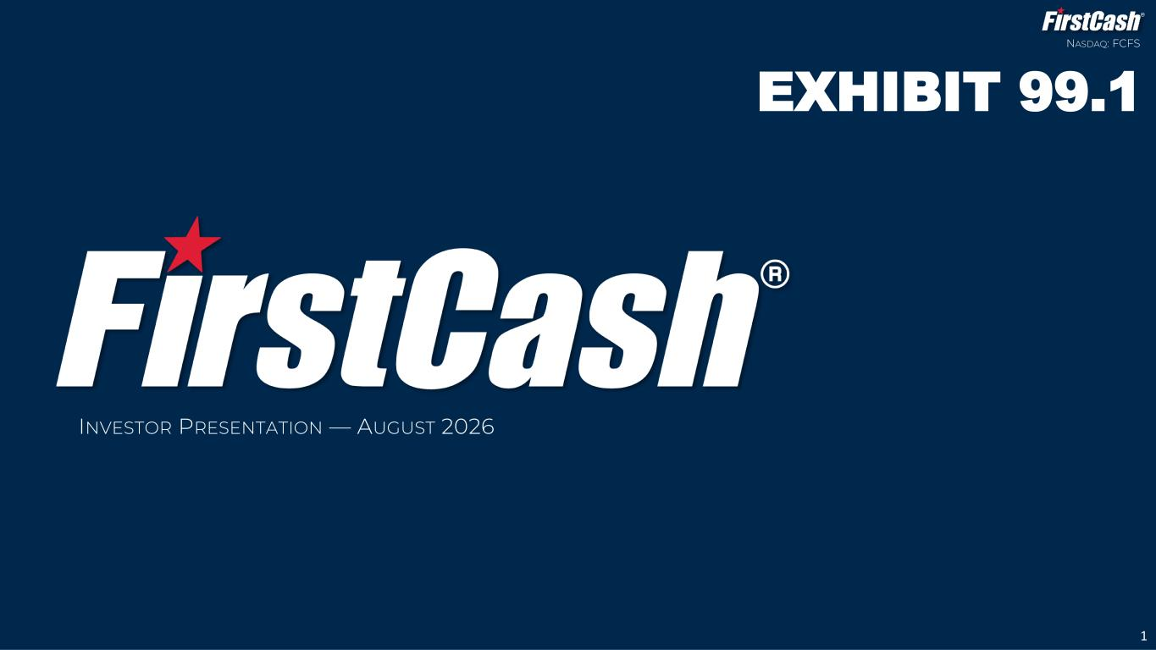
3
INVESTOR PRESENTATION — AUGUST 2026 1 NASDAQ: FCFS EXHIBIT 99.1

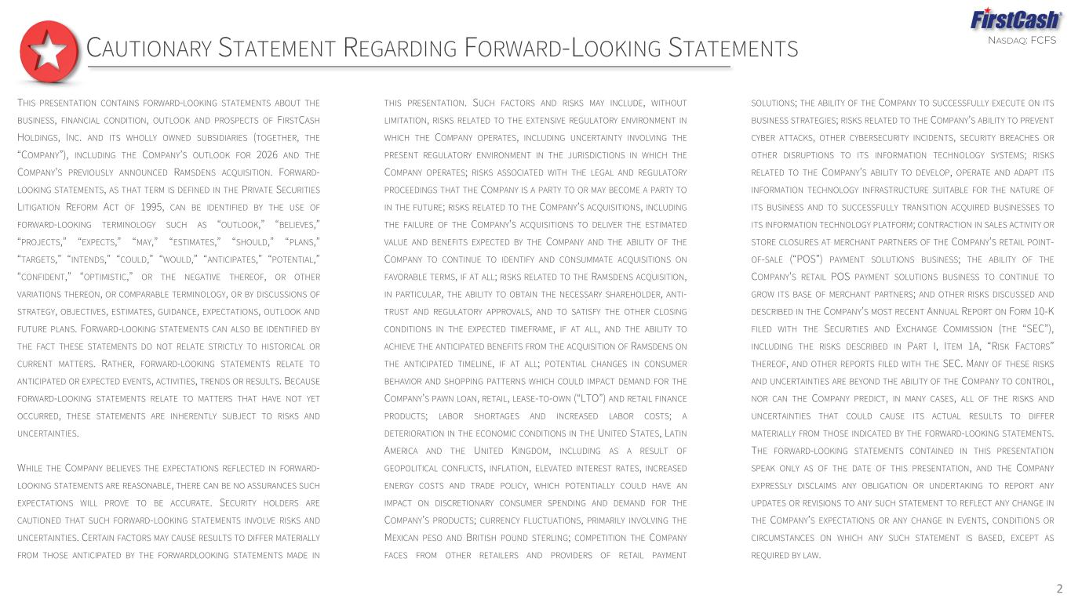
NASDAQ: FCFS 2 CAUTIONARY STATEMENT REGARDING FORWARD-LOOKING STATEMENTS THIS PRESENTATION CONTAINS FORWARD-LOOKING STATEMENTS ABOUT THE BUSINESS, FINANCIAL CONDITION, OUTLOOK AND PROSPECTS OF FIRSTCASH HOLDINGS, INC. AND ITS WHOLLY OWNED SUBSIDIARIES (TOGETHER, THE “COMPANY”), INCLUDING THE COMPANY’S OUTLOOK FOR 2026 AND THE COMPANY’S PREVIOUSLY ANNOUNCED RAMSDENS ACQUISITION. FORWARD- LOOKING STATEMENTS, AS THAT TERM IS DEFINED IN THE PRIVATE SECURITIES LITIGATION REFORM ACT OF 1995, CAN BE IDENTIFIED BY THE USE OF FORWARD-LOOKING TERMINOLOGY SUCH AS “OUTLOOK,” “BELIEVES,” “PROJECTS,” “EXPECTS,” “MAY,” “ESTIMATES,” “SHOULD,” “PLANS,” “TARGETS,” “INTENDS,” “COULD,” “WOULD,” “ANTICIPATES,” “POTENTIAL,” “CONFIDENT,” “OPTIMISTIC,” OR THE NEGATIVE THEREOF, OR OTHER VARIATIONS THEREON, OR COMPARABLE TERMINOLOGY, OR BY DISCUSSIONS OF STRATEGY, OBJECTIVES, ESTIMATES, GUIDANCE, EXPECTATIONS, OUTLOOK AND FUTURE PLANS. FORWARD-LOOKING STATEMENTS CAN ALSO BE IDENTIFIED BY THE FACT THESE STATEMENTS DO NOT RELATE STRICTLY TO HISTORICAL OR CURRENT MATTERS. RATHER, FORWARD-LOOKING STATEMENTS RELATE TO ANTICIPATED OR EXPECTED EVENTS, ACTIVITIES, TRENDS OR RESULTS. BECAUSE FORWARD-LOOKING STATEMENTS RELATE TO MATTERS THAT HAVE NOT YET OCCURRED, THESE STATEMENTS ARE INHERENTLY SUBJECT TO RISKS AND UNCERTAINTIES. WHILE THE COMPANY BELIEVES THE EXPECTATIONS REFLECTED IN FORWARD- LOOKING STATEMENTS ARE REASONABLE, THERE CAN BE NO ASSURANCES SUCH EXPECTATIONS WILL PROVE TO BE ACCURATE. SECURITY HOLDERS ARE CAUTIONED THAT SUCH FORWARD-LOOKING STATEMENTS INVOLVE RISKS AND UNCERTAINTIES. CERTAIN FACTORS MAY CAUSE RESULTS TO DIFFER MATERIALLY FROM THOSE ANTICIPATED BY THE FORWARDLOOKING STATEMENTS MADE IN THIS PRESENTATION. SUCH FACTORS AND RISKS MAY INCLUDE, WITHOUT LIMITATION, RISKS RELATED TO THE EXTENSIVE REGULATORY ENVIRONMENT IN WHICH THE COMPANY OPERATES, INCLUDING UNCERTAINTY INVOLVING THE PRESENT REGULATORY ENVIRONMENT IN THE JURISDICTIONS IN WHICH THE COMPANY OPERATES; RISKS ASSOCIATED WITH THE LEGAL AND REGULATORY PROCEEDINGS THAT THE COMPANY IS A PARTY TO OR MAY BECOME A PARTY TO IN THE FUTURE; RISKS RELATED TO THE COMPANY’S ACQUISITIONS, INCLUDING THE FAILURE OF THE COMPANY’S ACQUISITIONS TO DELIVER THE ESTIMATED VALUE AND BENEFITS EXPECTED BY THE COMPANY AND THE ABILITY OF THE COMPANY TO CONTINUE TO IDENTIFY AND CONSUMMATE ACQUISITIONS ON FAVORABLE TERMS, IF AT ALL; RISKS RELATED TO THE RAMSDENS ACQUISITION, IN PARTICULAR, THE ABILITY TO OBTAIN THE NECESSARY SHAREHOLDER, ANTI- TRUST AND REGULATORY APPROVALS, AND TO SATISFY THE OTHER CLOSING CONDITIONS IN THE EXPECTED TIMEFRAME, IF AT ALL, AND THE ABILITY TO ACHIEVE THE ANTICIPATED BENEFITS FROM THE ACQUISITION OF RAMSDENS ON THE ANTICIPATED TIMELINE, IF AT ALL; POTENTIAL CHANGES IN CONSUMER BEHAVIOR AND SHOPPING PATTERNS WHICH COULD IMPACT DEMAND FOR THE COMPANY’S PAWN LOAN, RETAIL, LEASE-TO-OWN (“LTO”) AND RETAIL FINANCE PRODUCTS; LABOR SHORTAGES AND INCREASED LABOR COSTS; A DETERIORATION IN THE ECONOMIC CONDITIONS IN THE UNITED STATES, LATIN AMERICA AND THE UNITED KINGDOM, INCLUDING AS A RESULT OF GEOPOLITICAL CONFLICTS, INFLATION, ELEVATED INTEREST RATES, INCREASED ENERGY COSTS AND TRADE POLICY, WHICH POTENTIALLY COULD HAVE AN IMPACT ON DISCRETIONARY CONSUMER SPENDING AND DEMAND FOR THE COMPANY’S PRODUCTS; CURRENCY FLUCTUATIONS, PRIMARILY INVOLVING THE MEXICAN PESO AND BRITISH POUND STERLING; COMPETITION THE COMPANY FACES FROM OTHER RETAILERS AND PROVIDERS OF RETAIL PAYMENT SOLUTIONS; THE ABILITY OF THE COMPANY TO SUCCESSFULLY EXECUTE ON ITS BUSINESS STRATEGIES; RISKS RELATED TO THE COMPANY’S ABILITY TO PREVENT CYBER ATTACKS, OTHER CYBERSECURITY INCIDENTS, SECURITY BREACHES OR OTHER DISRUPTIONS TO ITS INFORMATION TECHNOLOGY SYSTEMS; RISKS RELATED TO THE COMPANY’S ABILITY TO DEVELOP, OPERATE AND ADAPT ITS INFORMATION TECHNOLOGY INFRASTRUCTURE SUITABLE FOR THE NATURE OF ITS BUSINESS AND TO SUCCESSFULLY TRANSITION ACQUIRED BUSINESSES TO ITS INFORMATION TECHNOLOGY PLATFORM; CONTRACTION IN SALES ACTIVITY OR STORE CLOSURES AT MERCHANT PARTNERS OF THE COMPANY’S RETAIL POINT- OF-SALE (“POS”) PAYMENT SOLUTIONS BUSINESS; THE ABILITY OF THE COMPANY’S RETAIL POS PAYMENT SOLUTIONS BUSINESS TO CONTINUE TO GROW ITS BASE OF MERCHANT PARTNERS; AND OTHER RISKS DISCUSSED AND DESCRIBED IN THE COMPANY’S MOST RECENT ANNUAL REPORT ON FORM 10-K FILED WITH THE SECURITIES AND EXCHANGE COMMISSION (THE “SEC”), INCLUDING THE RISKS DESCRIBED IN PART I, ITEM 1A, “RISK FACTORS” THEREOF, AND OTHER REPORTS FILED WITH THE SEC. MANY OF THESE RISKS AND UNCERTAINTIES ARE BEYOND THE ABILITY OF THE COMPANY TO CONTROL, NOR CAN THE COMPANY PREDICT, IN MANY CASES, ALL OF THE RISKS AND UNCERTAINTIES THAT COULD CAUSE ITS ACTUAL RESULTS TO DIFFER MATERIALLY FROM THOSE INDICATED BY THE FORWARD-LOOKING STATEMENTS. THE FORWARD-LOOKING STATEMENTS CONTAINED IN THIS PRESENTATION SPEAK ONLY AS OF THE DATE OF THIS PRESENTATION, AND THE COMPANY EXPRESSLY DISCLAIMS ANY OBLIGATION OR UNDERTAKING TO REPORT ANY UPDATES OR REVISIONS TO ANY SUCH STATEMENT TO REFLECT ANY CHANGE IN THE COMPANY’S EXPECTATIONS OR ANY CHANGE IN EVENTS, CONDITIONS OR CIRCUMSTANCES ON WHICH ANY SUCH STATEMENT IS BASED, EXCEPT AS REQUIRED BY LAW.

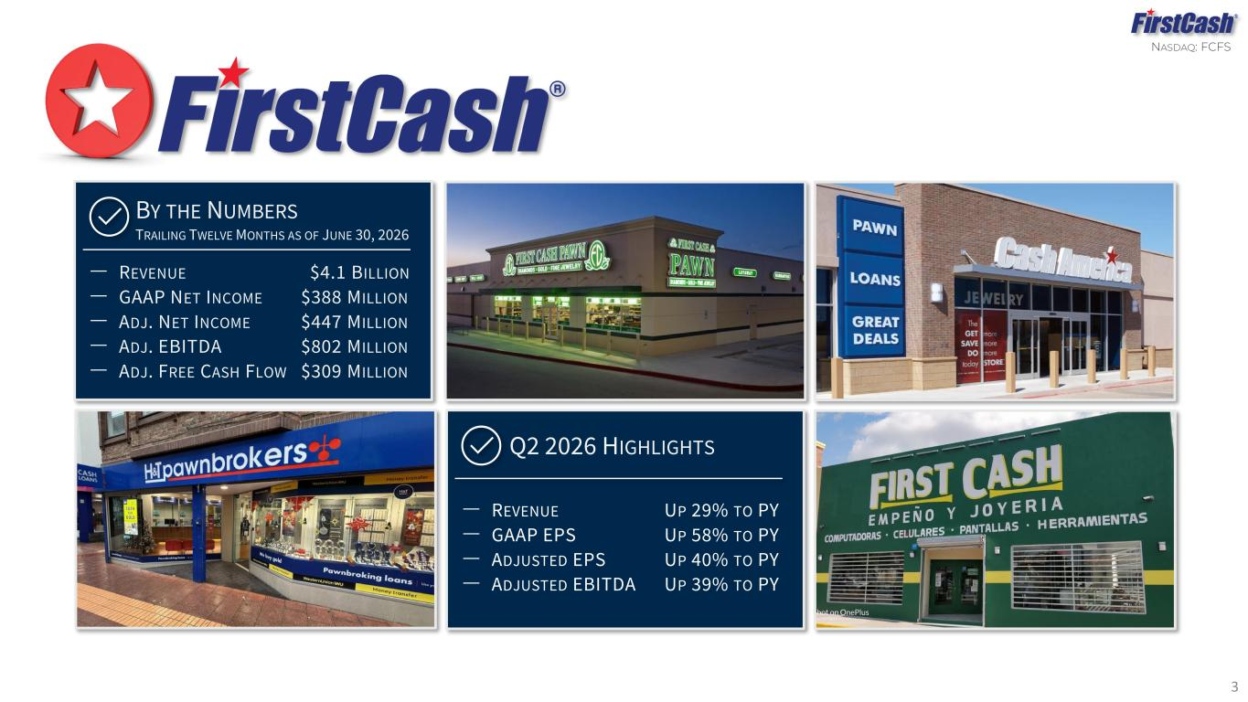
NASDAQ: FCFS 3 ‒ REVENUE UP 29% TO PY ‒ GAAP EPS UP 58% TO PY ‒ ADJUSTED EPS UP 40% TO PY ‒ ADJUSTED EBITDA UP 39% TO PY Q2 2026 HIGHLIGHTS ‒ REVENUE $4.1 BILLION ‒ GAAP NET INCOME $388 MILLION ‒ ADJ. NET INCOME $447 MILLION ‒ ADJ. EBITDA $802 MILLION ‒ ADJ. FREE CASH FLOW $309 MILLION BY THE NUMBERS TRAILING TWELVE MONTHS AS OF JUNE 30, 2026

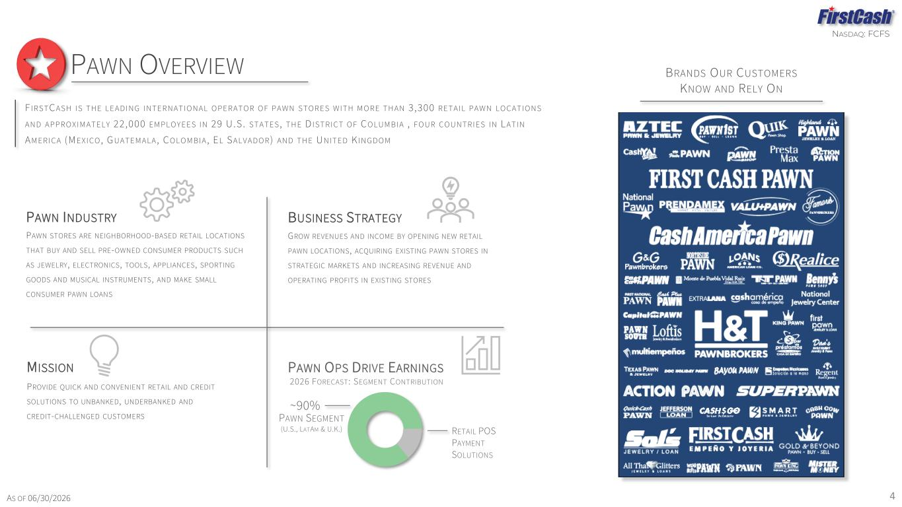
NASDAQ: FCFS F I RSTCASH I S THE LEADI NG I NTERNATI ONAL OPERATOR O F PAWN STORES WI TH M O RE THAN 3 ,300 RETAI L PAWN LOCATI ONS AND APPROXI M ATELY 22,000 EM PLOYEES I N 29 U.S. STATES , THE D I STRI CT O F C OLUM BI A , FOUR COUNTRI ES I N LATI N AM ERI CA (MEXI CO , G UATEM ALA , C OLOM BI A , EL SALVADOR ) AND THE UNI TED K I NGDO M PAWN OVERVIEW 4 BRANDS OUR CUSTOMERS KNOW AND RELY ON PROVIDE QUICK AND CONVENIENT RETAIL AND CREDIT SOLUTIONS TO UNBANKED, UNDERBANKED AND CREDIT-CHALLENGED CUSTOMERS MISSION GROW REVENUES AND INCOME BY OPENING NEW RETAIL PAWN LOCATIONS, ACQUIRING EXISTING PAWN STORES IN STRATEGIC MARKETS AND INCREASING REVENUE AND OPERATING PROFITS IN EXISTING STORES BUSINESS STRATEGY PAWN STORES ARE NEIGHBORHOOD-BASED RETAIL LOCATIONS THAT BUY AND SELL PRE-OWNED CONSUMER PRODUCTS SUCH AS JEWELRY, ELECTRONICS, TOOLS, APPLIANCES, SPORTING GOODS AND MUSICAL INSTRUMENTS, AND MAKE SMALL CONSUMER PAWN LOANS PAWN INDUSTRY 2026 FORECAST: SEGMENT CONTRIBUTION PAWN OPS DRIVE EARNINGS PAWN SEGMENT (U.S., LATAM & U.K.) ~90% AS OF 06/30/2026 RETAIL POS PAYMENT SOLUTIONS

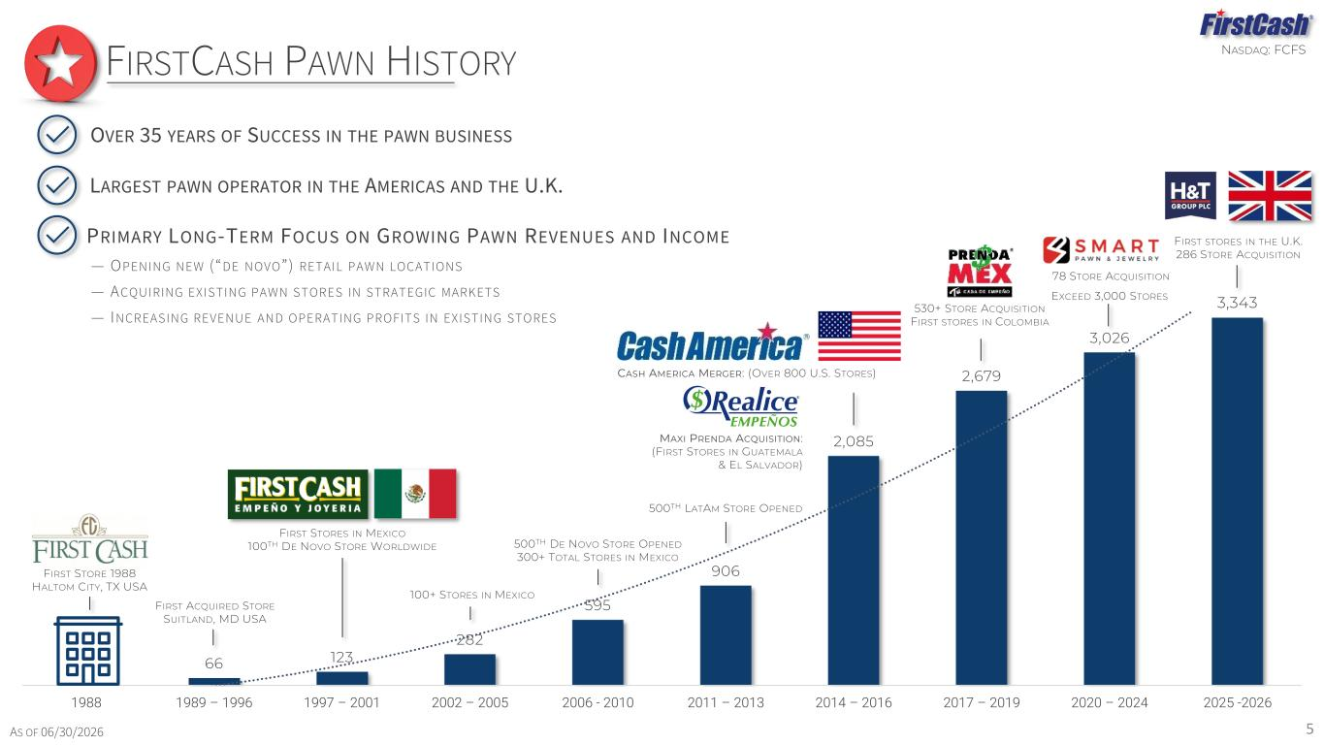
NASDAQ: FCFS 66 123 282 595 906 2,085 2,679 3,026 3,343 1988 1989 – 1996 1997 – 2001 2002 – 2005 2006 - 2010 2011 – 2013 2014 – 2016 2017 – 2019 2020 – 2024 2025 -2026 FIRST ACQUIRED STORE SUITLAND, MD USA FIRST STORE 1988 HALTOM CITY, TX USA 100+ STORES IN MEXICO 500TH LATAM STORE OPENED 500TH DE NOVO STORE OPENED 300+ TOTAL STORES IN MEXICO FIRSTCASH PAWN HISTORY 5AS OF 06/30/2026 FIRST STORES IN THE U.K. 286 STORE ACQUISITION 530+ STORE ACQUISITION FIRST STORES IN COLOMBIA 78 STORE ACQUISITION EXCEED 3,000 STORES FIRST STORES IN MEXICO 100TH DE NOVO STORE WORLDWIDE MAXI PRENDA ACQUISITION: (FIRST STORES IN GUATEMALA & EL SALVADOR) CASH AMERICA MERGER: (OVER 800 U.S. STORES) PRIMARY LONG-TERM FOCUS ON GROWING PAWN REVENUES AND INCOME — OPENING NEW (“DE NOVO”) RETAIL PAWN LOCATIONS — ACQUIRING EXISTING PAWN STORES IN STRATEGIC MARKETS — INCREASING REVENUE AND OPERATING PROFITS IN EXISTING STORES LARGEST PAWN OPERATOR IN THE AMERICAS AND THE U.K. OVER 35 YEARS OF SUCCESS IN THE PAWN BUSINESS

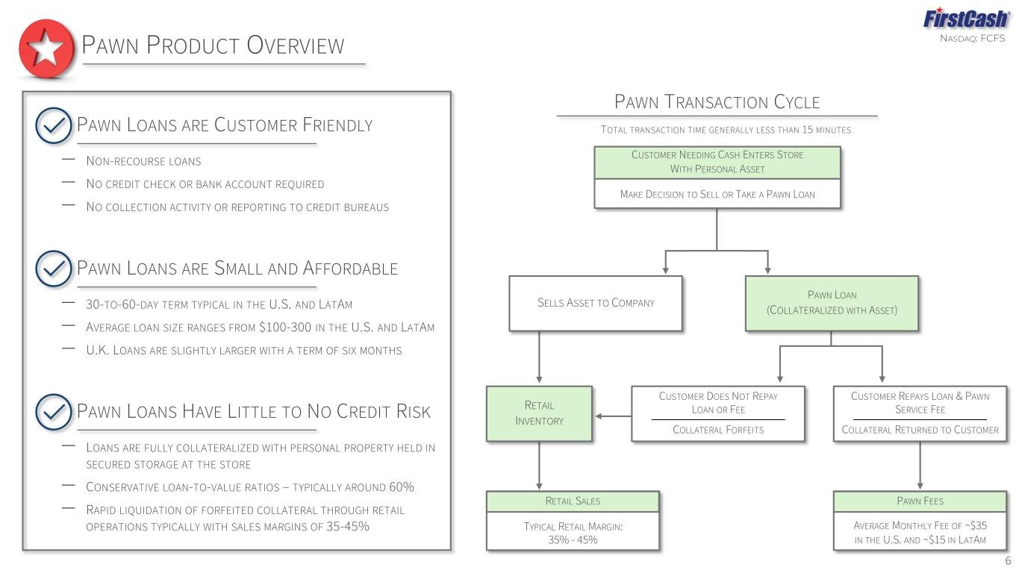
NASDAQ: FCFS 6 PAWN PRODUCT OVERVIEW TYPICAL RETAIL MARGIN: 35% - 45% AVERAGE MONTHLY FEE OF ~$35 IN THE U.S. AND ~$15 IN LATAM CUSTOMER DOES NOT REPAY LOAN OR FEE COLLATERAL FORFEITS CUSTOMER REPAYS LOAN & PAWN SERVICE FEE COLLATERAL RETURNED TO CUSTOMER MAKE DECISION TO SELL OR TAKE A PAWN LOAN SELLS ASSET TO COMPANY PAWN LOAN (COLLATERALIZED WITH ASSET) RETAIL INVENTORY RETAIL SALES PAWN FEES CUSTOMER NEEDING CASH ENTERS STORE WITH PERSONAL ASSET PAWN TRANSACTION CYCLE TOTAL TRANSACTION TIME GENERALLY LESS THAN 15 MINUTESPAWN LOANS ARE CUSTOMER FRIENDLY ‒ NON-RECOURSE LOANS ‒ NO CREDIT CHECK OR BANK ACCOUNT REQUIRED ‒ NO COLLECTION ACTIVITY OR REPORTING TO CREDIT BUREAUS PAWN LOANS ARE SMALL AND AFFORDABLE ‒ 30-TO-60-DAY TERM TYPICAL IN THE U.S. AND LATAM ‒ AVERAGE LOAN SIZE RANGES FROM $100-300 IN THE U.S. AND LATAM ‒ U.K. LOANS ARE SLIGHTLY LARGER WITH A TERM OF SIX MONTHS PAWN LOANS HAVE LITTLE TO NO CREDIT RISK ‒ LOANS ARE FULLY COLLATERALIZED WITH PERSONAL PROPERTY HELD IN SECURED STORAGE AT THE STORE ‒ CONSERVATIVE LOAN-TO-VALUE RATIOS – TYPICALLY AROUND 60% ‒ RAPID LIQUIDATION OF FORFEITED COLLATERAL THROUGH RETAIL OPERATIONS TYPICALLY WITH SALES MARGINS OF 35-45%

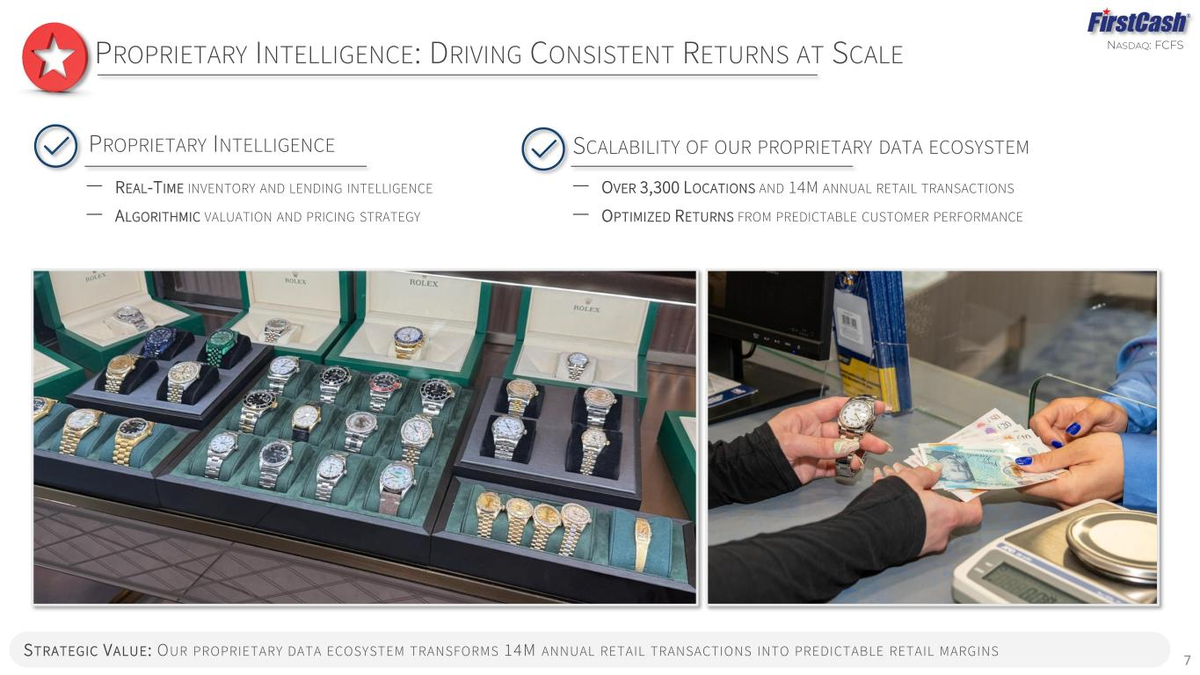
NASDAQ: FCFS 7 PROPRIETARY INTELLIGENCE: DRIVING CONSISTENT RETURNS AT SCALE STRATEGIC VALUE: OUR PROPRIETARY DATA ECOSYSTEM TRANSFORMS 14M ANNUAL RETAIL TRANSACTIONS INTO PREDICTABLE RETAIL MARGINS PROPRIETARY INTELLIGENCE ‒ REAL-TIME INVENTORY AND LENDING INTELLIGENCE ‒ ALGORITHMIC VALUATION AND PRICING STRATEGY SCALABILITY OF OUR PROPRIETARY DATA ECOSYSTEM ‒ OVER 3,300 LOCATIONS AND 14M ANNUAL RETAIL TRANSACTIONS ‒ OPTIMIZED RETURNS FROM PREDICTABLE CUSTOMER PERFORMANCE

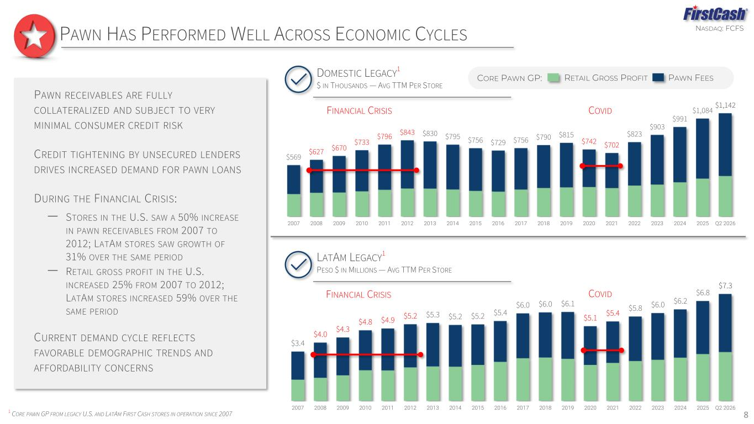
NASDAQ: FCFS 8 PAWN HAS PERFORMED WELL ACROSS ECONOMIC CYCLES 1 CORE PAWN GP FROM LEGACY U.S. AND LATAM FIRST CASH STORES IN OPERATION SINCE 2007 CORE PAWN GP: RETAIL GROSS PROFIT PAWN FEES PAWN RECEIVABLES ARE FULLY COLLATERALIZED AND SUBJECT TO VERY MINIMAL CONSUMER CREDIT RISK CREDIT TIGHTENING BY UNSECURED LENDERS DRIVES INCREASED DEMAND FOR PAWN LOANS DURING THE FINANCIAL CRISIS: ‒ STORES IN THE U.S. SAW A 50% INCREASE IN PAWN RECEIVABLES FROM 2007 TO 2012; LATAM STORES SAW GROWTH OF 31% OVER THE SAME PERIOD ‒ RETAIL GROSS PROFIT IN THE U.S. INCREASED 25% FROM 2007 TO 2012; LATAM STORES INCREASED 59% OVER THE SAME PERIOD CURRENT DEMAND CYCLE REFLECTS FAVORABLE DEMOGRAPHIC TRENDS AND AFFORDABILITY CONCERNS $3.4 $4.0 $4.3 $4.8 $4.9 $5.2 $5.3 $5.2 $5.2 $5.4 $6.0 $6.0 $6.1 $5.1 $5.4 $5.8 $6.0 $6.2 $6.8 $7.3 2007 2008 2009 2010 2011 2012 2013 2014 2015 2016 2017 2018 2019 2020 2021 2022 2023 2024 2025 Q2 2026 LATAM LEGACY 1 PESO $ IN MILLIONS — AVG TTM PER STORE FINANCIAL CRISIS COVID $569 $627 $670 $733 $796 $843 $830 $795 $756 $729 $756 $790 $815 $742 $702 $823 $903 $991 $1,084 $1,142 2007 2008 2009 2010 2011 2012 2013 2014 2015 2016 2017 2018 2019 2020 2021 2022 2023 2024 2025 Q2 2026 DOMESTIC LEGACY 1 $ IN THOUSANDS — AVG TTM PER STORE FINANCIAL CRISIS COVID

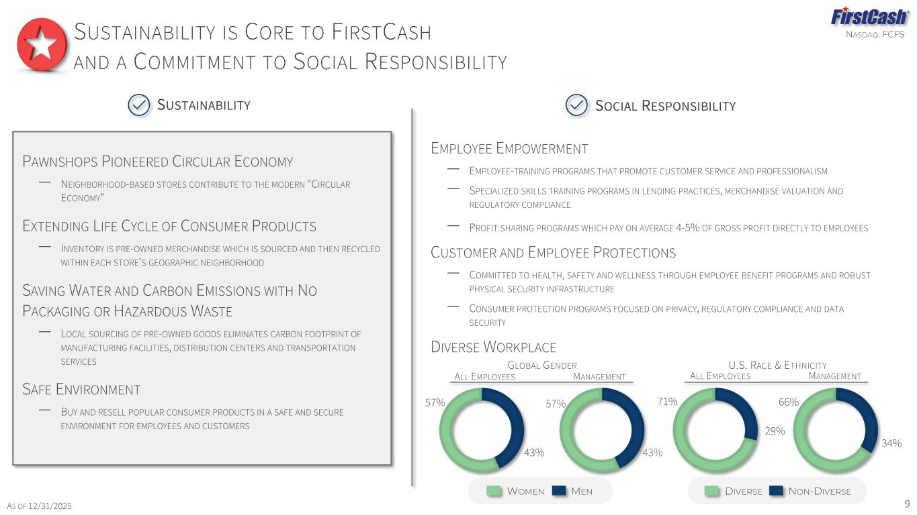
NASDAQ: FCFS PAWNSHOPS PIONEERED CIRCULAR ECONOMY ‒ NEIGHBORHOOD-BASED STORES CONTRIBUTE TO THE MODERN “CIRCULAR ECONOMY” EXTENDING LIFE CYCLE OF CONSUMER PRODUCTS – INVENTORY IS PRE-OWNED MERCHANDISE WHICH IS SOURCED AND THEN RECYCLED WITHIN EACH STORE’S GEOGRAPHIC NEIGHBORHOOD SAVING WATER AND CARBON EMISSIONS WITH NO PACKAGING OR HAZARDOUS WASTE ‒ LOCAL SOURCING OF PRE-OWNED GOODS ELIMINATES CARBON FOOTPRINT OF MANUFACTURING FACILITIES, DISTRIBUTION CENTERS AND TRANSPORTATION SERVICES SAFE ENVIRONMENT ‒ BUY AND RESELL POPULAR CONSUMER PRODUCTS IN A SAFE AND SECURE ENVIRONMENT FOR EMPLOYEES AND CUSTOMERS EMPLOYEE EMPOWERMENT ‒ EMPLOYEE-TRAINING PROGRAMS THAT PROMOTE CUSTOMER SERVICE AND PROFESSIONALISM ‒ SPECIALIZED SKILLS TRAINING PROGRAMS IN LENDING PRACTICES, MERCHANDISE VALUATION AND REGULATORY COMPLIANCE ‒ PROFIT SHARING PROGRAMS WHICH PAY ON AVERAGE 4-5% OF GROSS PROFIT DIRECTLY TO EMPLOYEES CUSTOMER AND EMPLOYEE PROTECTIONS – COMMITTED TO HEALTH, SAFETY AND WELLNESS THROUGH EMPLOYEE BENEFIT PROGRAMS AND ROBUST PHYSICAL SECURITY INFRASTRUCTURE – CONSUMER PROTECTION PROGRAMS FOCUSED ON PRIVACY, REGULATORY COMPLIANCE AND DATA SECURITY DIVERSE WORKPLACE 57% 43% ALL EMPLOYEES MANAGEMENT GLOBAL GENDER 57% 43% 66% 34% 71% 29% ALL EMPLOYEES MANAGEMENT U.S. RACE & ETHNICITY SUSTAINABILITY IS CORE TO FIRSTCASH AND A COMMITMENT TO SOCIAL RESPONSIBILITY WOMEN MEN DIVERSE NON-DIVERSE AS OF 12/31/2025 9 SUSTAINABILITY SOCIAL RESPONSIBILITY

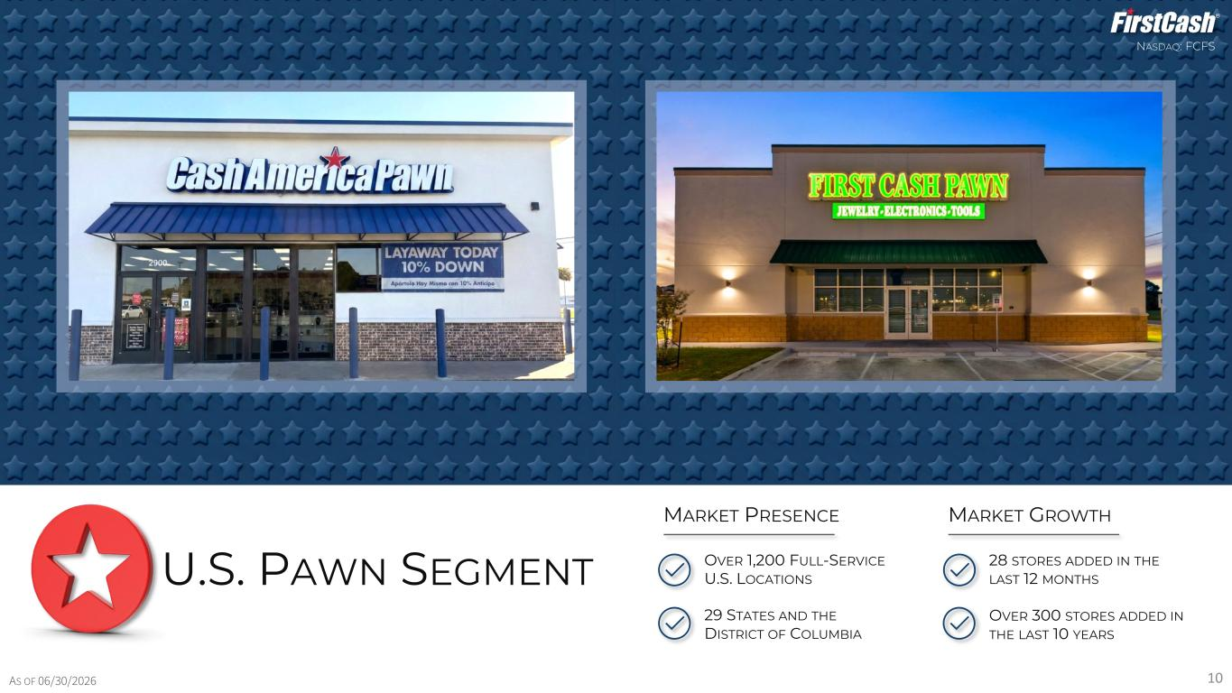
NASDAQ: FCFS 10 U.S. PAWN SEGMENT OVER 1,200 FULL-SERVICE U.S. LOCATIONS 29 STATES AND THE DISTRICT OF COLUMBIA MARKET PRESENCE 28 STORES ADDED IN THE LAST 12 MONTHS OVER 300 STORES ADDED IN THE LAST 10 YEARS MARKET GROWTH AS OF 06/30/2026

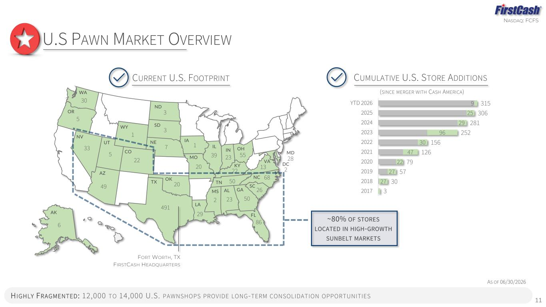
NASDAQ: FCFS 11 AS OF 06/30/2026 U.S PAWN MARKET OVERVIEW ~80% OF STORES LOCATED IN HIGH-GROWTH SUNBELT MARKETS H IGHLY FRAGMENTED : 12,000 TO 14,000 U.S. PAWNSHOPS PROVIDE LONG-TERM CONSOLIDATION OPPORTUNITIES CUMULATIVE U.S. STORE ADDITIONS (SINCE MERGER WITH CASH AMERICA) 27 27 22 47 30 96 29 25 9 3 30 57 79 126 156 252 281 306 315 2017 2018 2019 2020 2021 2022 2023 2024 2025 YTD 2026 NV AK WA LA UT NE AZ CO TX MO OK IL IN OH GAAL FL KY TN NC VA WY SC 30 33 49 491 6 1 5 22 7 20 39 29 20 23 68 55 5023 86 50 22 13 26 MD 28 DC 2 FORT WORTH, TX FIRSTCASH HEADQUARTERS 2 MS 5 3 3 1 OR ND SD IA CURRENT U.S. FOOTPRINT

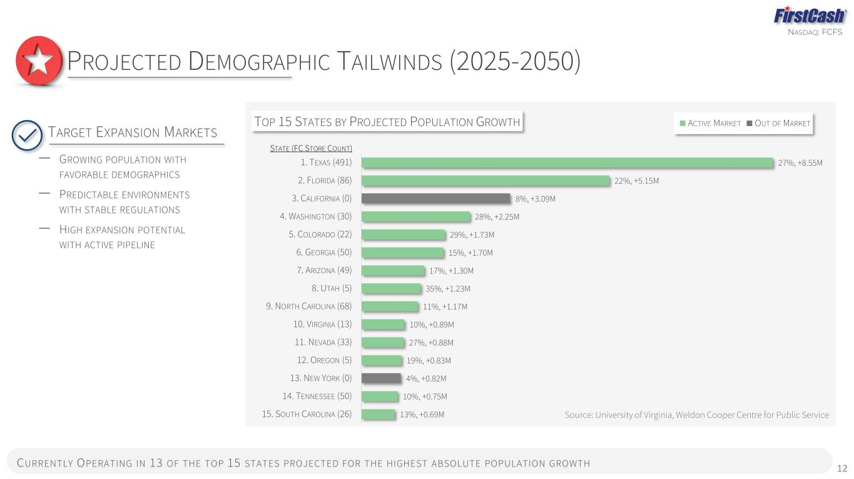
NASDAQ: FCFS 27%, +8.55M 22%, +5.15M 8%, +3.09M 28%, +2.25M 29%, +1.73M 15%, +1.70M 17%, +1.30M 35%, +1.23M 11%, +1.17M 10%, +0.89M 27%, +0.88M 19%, +0.83M 4%, +0.82M 10%, +0.75M 13%, +0.69M 1. TEXAS (491) 2. FLORIDA (86) 3. CALIFORNIA (0) 4. WASHINGTON (30) 5. COLORADO (22) 6. GEORGIA (50) 7. ARIZONA (49) 8. UTAH (5) 9. NORTH CAROLINA (68) 10. VIRGINIA (13) 11. NEVADA (33) 12. OREGON (5) 13. NEW YORK (0) 14. TENNESSEE (50) 15. SOUTH CAROLINA (26) TOP 15 STATES BY PROJECTED POPULATION GROWTH ACTIVE MARKET OUT OF MARKET 12 PROJECTED DEMOGRAPHIC TAILWINDS (2025-2050) TARGET EXPANSION MARKETS ‒ GROWING POPULATION WITH FAVORABLE DEMOGRAPHICS ‒ PREDICTABLE ENVIRONMENTS WITH STABLE REGULATIONS ‒ HIGH EXPANSION POTENTIAL WITH ACTIVE PIPELINE CURRENTLY OPERATING IN 13 OF THE TOP 15 STATES PROJECTED FOR THE HIGHEST ABSOLUTE POPULATION GROWTH Source: University of Virginia, Weldon Cooper Centre for Public Service STATE (FC STORE COUNT)

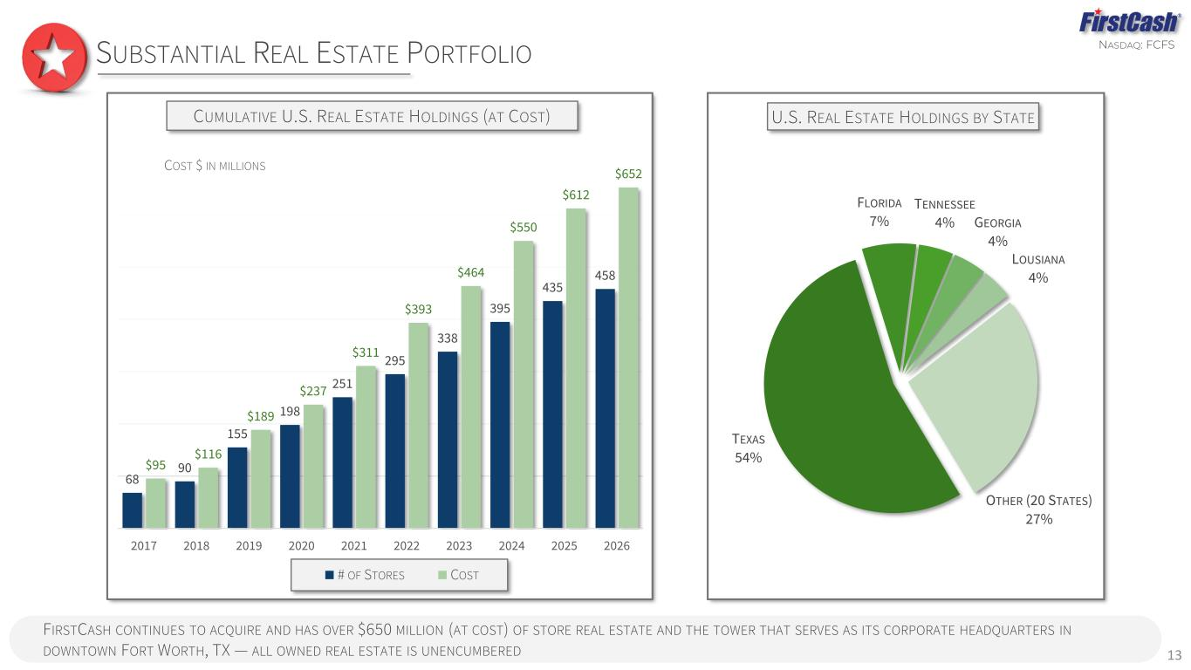
NASDAQ: FCFS 13 SUBSTANTIAL REAL ESTATE PORTFOLIO 68 90 155 198 251 295 338 395 435 458 $95 $116 $189 $237 $311 $393 $464 $550 $612 $652 2017 2018 2019 2020 2021 2022 2023 2024 2025 2026 # OF STORES COST COST $ IN MILLIONS TEXAS 54% FLORIDA 7% TENNESSEE 4% GEORGIA 4% LOUSIANA 4% OTHER (20 STATES) 27% U.S. REAL ESTATE HOLDINGS BY STATECUMULATIVE U.S. REAL ESTATE HOLDINGS (AT COST) FIRSTCASH CONTINUES TO ACQUIRE AND HAS OVER $650 MILLION (AT COST) OF STORE REAL ESTATE AND THE TOWER THAT SERVES AS ITS CORPORATE HEADQUARTERS IN DOWNTOWN FORT WORTH, TX — ALL OWNED REAL ESTATE IS UNENCUMBERED

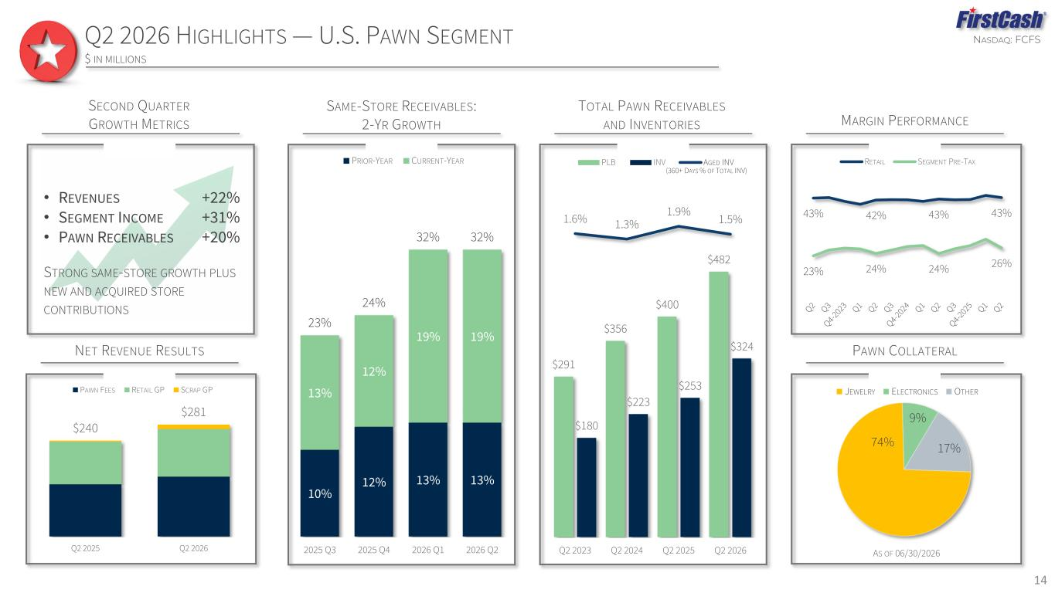
NASDAQ: FCFS SECOND QUARTER GROWTH METRICS 10% 12% 13% 13% 13% 12% 19% 19% 23% 24% 32% 32% 2025 Q3 2025 Q4 2026 Q1 2026 Q2 PRIOR-YEAR CURRENT-YEAR SAME-STORE RECEIVABLES: 2-YR GROWTH 43% 42% 43% 43% 23% 24% 24% 26% RETAIL SEGMENT PRE-TAX MARGIN PERFORMANCE $291 $356 $400 $482 $180 $223 $253 $324 1.6% 1.3% 1.9% 1.5% -12.0%$0 $200 $400 $600 Q2 2023 Q2 2024 Q2 2025 Q2 2026 PLB INV AGED INV TOTAL PAWN RECEIVABLES AND INVENTORIES 14 PAWN COLLATERAL 74% 9% 17% JEWELRY ELECTRONICS OTHER AS OF 06/30/2026 Q2 2026 HIGHLIGHTS — U.S. PAWN SEGMENT $ IN MILLIONS (360+ DAYS % OF TOTAL INV) NET REVENUE RESULTS $240 $281 Q2 2025 Q2 2026 PAWN FEES RETAIL GP SCRAP GP • REVENUES +22% • SEGMENT INCOME +31% • PAWN RECEIVABLES +20% STRONG SAME-STORE GROWTH PLUS NEW AND ACQUIRED STORE CONTRIBUTIONS

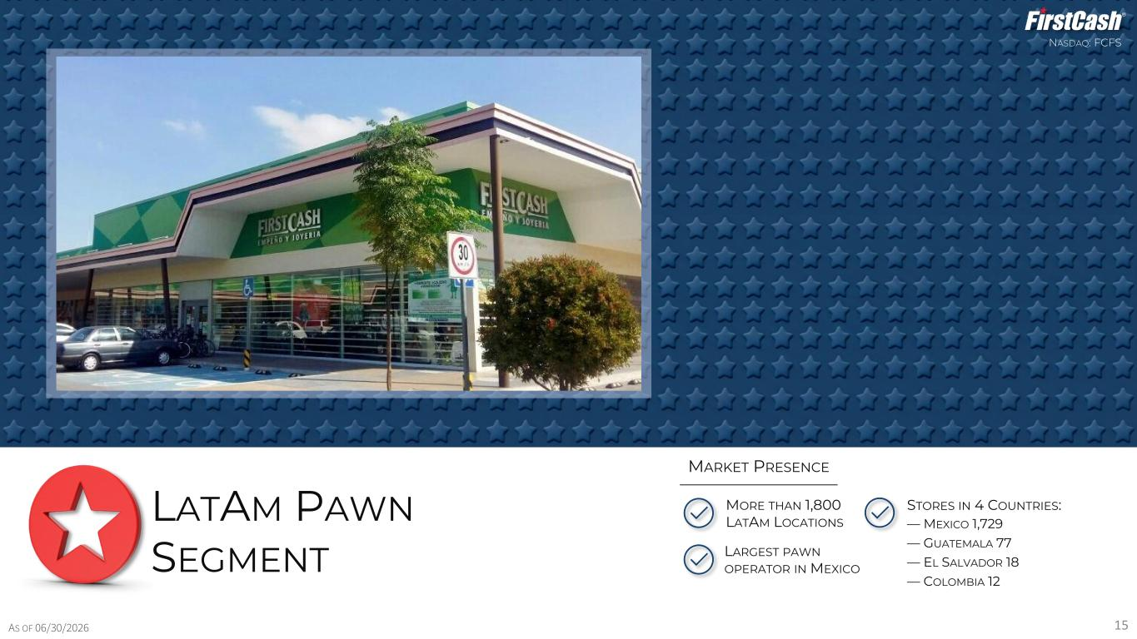
NASDAQ: FCFS STORES IN 4 COUNTRIES: — MEXICO 1,729 — GUATEMALA 77 — EL SALVADOR 18 — COLOMBIA 12 LARGEST PAWN OPERATOR IN MEXICO 15 LATAM PAWN SEGMENT MORE THAN 1,800 LATAM LOCATIONS MARKET PRESENCE AS OF 06/30/2026

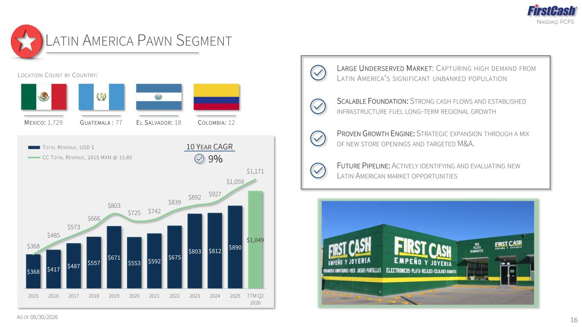
NASDAQ: FCFS MEXICO: 1,729 LOCATION COUNT BY COUNTRY: EL SALVADOR: 18 COLOMBIA: 12GUATEMALA : 77 16 LATIN AMERICA PAWN SEGMENT AS OF 06/30/2026 LARGE UNDERSERVED MARKET: CAPTURING HIGH DEMAND FROM LATIN AMERICA’S SIGNIFICANT UNBANKED POPULATION FUTURE PIPELINE: ACTIVELY IDENTIFYING AND EVALUATING NEW LATIN AMERICAN MARKET OPPORTUNITIES SCALABLE FOUNDATION: STRONG CASH FLOWS AND ESTABLISHED INFRASTRUCTURE FUEL LONG-TERM REGIONAL GROWTH PROVEN GROWTH ENGINE: STRATEGIC EXPANSION THROUGH A MIX OF NEW STORE OPENINGS AND TARGETED M&A. $368 $417 $487 $557 $671 $553 $592 $675 $803 $812 $890 $1,049 $368 $485 $573 $666 $803 $725 $742 $839 $892 $927 $1,059 $1,171 2015 2016 2017 2018 2019 2020 2021 2022 2023 2024 2025 TTM Q2 2026 TOTAL REVENUE, USD $ CC TOTAL REVENUE, 2015 MXN @ 15.85 9% 10 YEAR CAGR

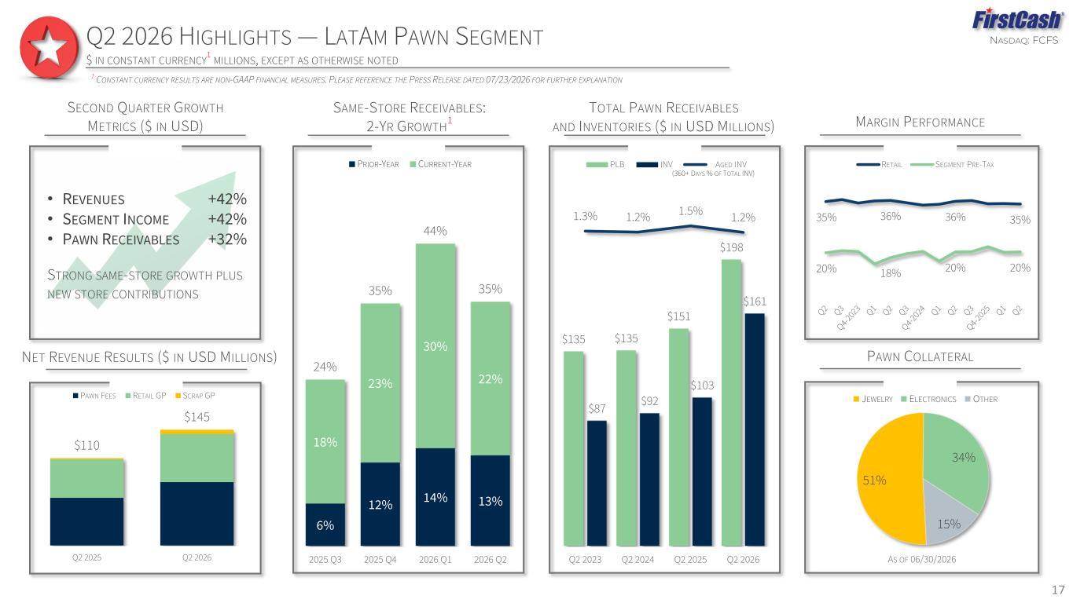
NASDAQ: FCFS 51% 34% 15% JEWELRY ELECTRONICS OTHER SECOND QUARTER GROWTH METRICS ($ IN USD) 6% 12% 14% 13% 18% 23% 30% 22% 24% 35% 44% 35% 2025 Q3 2025 Q4 2026 Q1 2026 Q2 PRIOR-YEAR CURRENT-YEAR SAME-STORE RECEIVABLES: 2-YR GROWTH 1 35% 36% 36% 35% 20% 18% 20% 20% RETAIL SEGMENT PRE-TAX $135 $135 $151 $198 $87 $92 $103 $161 1.3% 1.2% 1.5% 1.2% -12.0% -11.0% -10.0% -9.0% -8.0% -7.0% -6.0% -5.0% -4.0% -3.0% -2.0% -1.0% 0.0% 1.0% 2.0% $0 $75 $150 $225 Q2 2023 Q2 2024 Q2 2025 Q2 2026 PLB INV AGED INV TOTAL PAWN RECEIVABLES AND INVENTORIES ($ IN USD MILLIONS) Q2 2026 HIGHLIGHTS — LATAM PAWN SEGMENT $ IN CONSTANT CURRENCY 1 MILLIONS, EXCEPT AS OTHERWISE NOTED PAWN COLLATERAL MARGIN PERFORMANCE AS OF 06/30/2026 1 CONSTANT CURRENCY RESULTS ARE NON-GAAP FINANCIAL MEASURES. PLEASE REFERENCE THE PRESS RELEASE DATED 07/23/2026 FOR FURTHER EXPLANATION (360+ DAYS % OF TOTAL INV) NET REVENUE RESULTS ($ IN USD MILLIONS) $110 $145 Q2 2025 Q2 2026 PAWN FEES RETAIL GP SCRAP GP • REVENUES +42% • SEGMENT INCOME +42% • PAWN RECEIVABLES +32% STRONG SAME-STORE GROWTH PLUS NEW STORE CONTRIBUTIONS 17

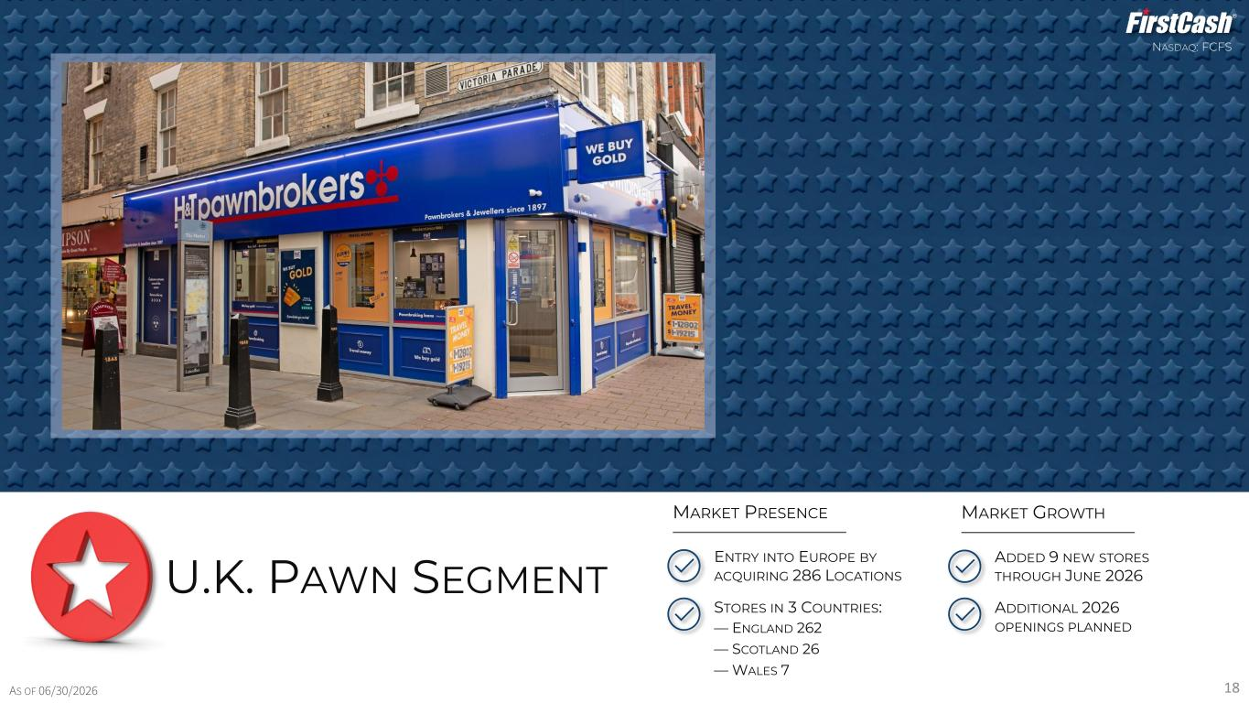
NASDAQ: FCFS 18 U.K. PAWN SEGMENT AS OF 06/30/2026 STORES IN 3 COUNTRIES: — ENGLAND 262 — SCOTLAND 26 — WALES 7 ENTRY INTO EUROPE BY ACQUIRING 286 LOCATIONS MARKET PRESENCE ADDED 9 NEW STORES THROUGH JUNE 2026 MARKET GROWTH ADDITIONAL 2026 OPENINGS PLANNED

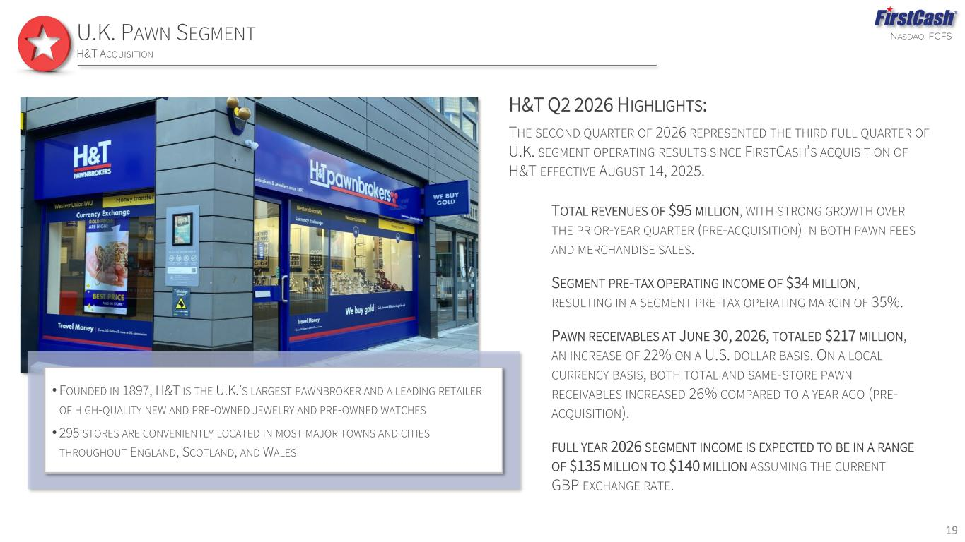
NASDAQ: FCFSU.K. PAWN SEGMENT H&T ACQUISITION 19 • FOUNDED IN 1897, H&T IS THE U.K.’S LARGEST PAWNBROKER AND A LEADING RETAILER OF HIGH-QUALITY NEW AND PRE-OWNED JEWELRY AND PRE-OWNED WATCHES • 295 STORES ARE CONVENIENTLY LOCATED IN MOST MAJOR TOWNS AND CITIES THROUGHOUT ENGLAND, SCOTLAND, AND WALES H&T Q2 2026 HIGHLIGHTS: THE SECOND QUARTER OF 2026 REPRESENTED THE THIRD FULL QUARTER OF U.K. SEGMENT OPERATING RESULTS SINCE FIRSTCASH’S ACQUISITION OF H&T EFFECTIVE AUGUST 14, 2025. TOTAL REVENUES OF $95 MILLION, WITH STRONG GROWTH OVER THE PRIOR-YEAR QUARTER (PRE-ACQUISITION) IN BOTH PAWN FEES AND MERCHANDISE SALES. SEGMENT PRE-TAX OPERATING INCOME OF $34 MILLION, RESULTING IN A SEGMENT PRE-TAX OPERATING MARGIN OF 35%. PAWN RECEIVABLES AT JUNE 30, 2026, TOTALED $217 MILLION, AN INCREASE OF 22% ON A U.S. DOLLAR BASIS. ON A LOCAL CURRENCY BASIS, BOTH TOTAL AND SAME-STORE PAWN RECEIVABLES INCREASED 26% COMPARED TO A YEAR AGO (PRE- ACQUISITION). FULL YEAR 2026 SEGMENT INCOME IS EXPECTED TO BE IN A RANGE OF $135 MILLION TO $140 MILLION ASSUMING THE CURRENT GBP EXCHANGE RATE.

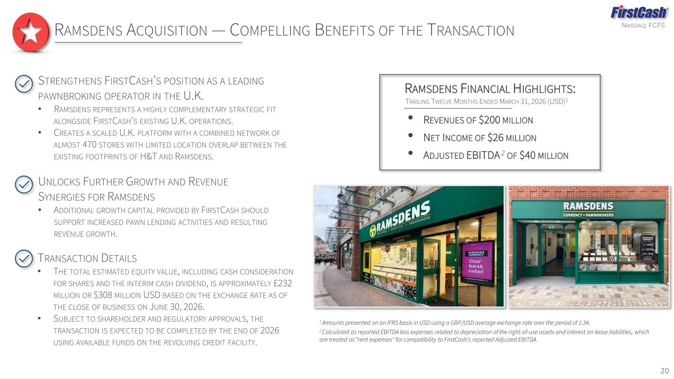
NASDAQ: FCFS 20 RAMSDENS ACQUISITION — COMPELLING BENEFITS OF THE TRANSACTION 1 Amounts presented on an IFRS basis in USD using a GBP/USD average exchange rate over the period of 1.34. 2 Calculated as reported EBITDA less expenses related to depreciation of the right-of-use assets and interest on lease liabilities, which are treated as “rent expenses" for compatibility to FirstCash’s reported Adjusted EBITDA. STRENGTHENS FIRSTCASH’S POSITION AS A LEADING PAWNBROKING OPERATOR IN THE U.K. • RAMSDENS REPRESENTS A HIGHLY COMPLEMENTARY STRATEGIC FIT ALONGSIDE FIRSTCASH’S EXISTING U.K. OPERATIONS. • CREATES A SCALED U.K. PLATFORM WITH A COMBINED NETWORK OF ALMOST 470 STORES WITH LIMITED LOCATION OVERLAP BETWEEN THE EXISTING FOOTPRINTS OF H&T AND RAMSDENS. UNLOCKS FURTHER GROWTH AND REVENUE SYNERGIES FOR RAMSDENS • ADDITIONAL GROWTH CAPITAL PROVIDED BY FIRSTCASH SHOULD SUPPORT INCREASED PAWN LENDING ACTIVITIES AND RESULTING REVENUE GROWTH. TRANSACTION DETAILS • THE TOTAL ESTIMATED EQUITY VALUE, INCLUDING CASH CONSIDERATION FOR SHARES AND THE INTERIM CASH DIVIDEND, IS APPROXIMATELY £232 MILLION OR $308 MILLION USD BASED ON THE EXCHANGE RATE AS OF THE CLOSE OF BUSINESS ON JUNE 30, 2026. • SUBJECT TO SHAREHOLDER AND REGULATORY APPROVALS, THE TRANSACTION IS EXPECTED TO BE COMPLETED BY THE END OF 2026 USING AVAILABLE FUNDS ON THE REVOLVING CREDIT FACILITY. RAMSDENS FINANCIAL HIGHLIGHTS: • REVENUES OF $200 MILLION • NET INCOME OF $26 MILLION • ADJUSTED EBITDA 2 OF $40 MILLION TRAILING TWELVE MONTHS ENDED MARCH 31, 2026 (USD)1


NASDAQ: FCFS 21 RETAIL POS PAYMENT SOLUTIONS SEGMENT

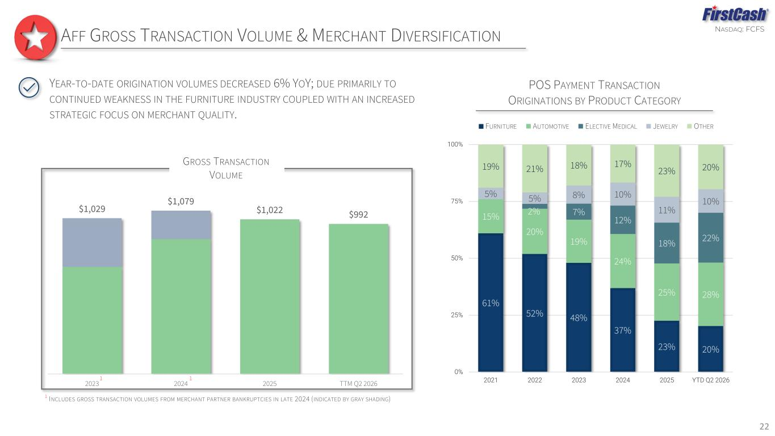
NASDAQ: FCFS AFF GROSS TRANSACTION VOLUME & MERCHANT DIVERSIFICATION 22 POS PAYMENT TRANSACTION ORIGINATIONS BY PRODUCT CATEGORY 61% 52% 48% 37% 23% 20% 15% 20% 19% 24% 25% 28% 2% 7% 12% 18% 22% 5% 5% 8% 10% 11% 10% 19% 21% 18% 17% 23% 20% 0% 25% 50% 75% 100% 2021 2022 2023 2024 2025 YTD Q2 2026 FURNITURE AUTOMOTIVE ELECTIVE MEDICAL JEWELRY OTHER YEAR-TO-DATE ORIGINATION VOLUMES DECREASED 6% YOY; DUE PRIMARILY TO CONTINUED WEAKNESS IN THE FURNITURE INDUSTRY COUPLED WITH AN INCREASED STRATEGIC FOCUS ON MERCHANT QUALITY. $1,029 $1,079 $1,022 $992 2023 2024 2025 TTM Q2 2026 GROSS TRANSACTION VOLUME 1 1 1 INCLUDES GROSS TRANSACTION VOLUMES FROM MERCHANT PARTNER BANKRUPTCIES IN LATE 2024 (INDICATED BY GRAY SHADING)


NASDAQ: FCFS 23 CONSOLIDATED FINANCIAL HIGHLIGHTS

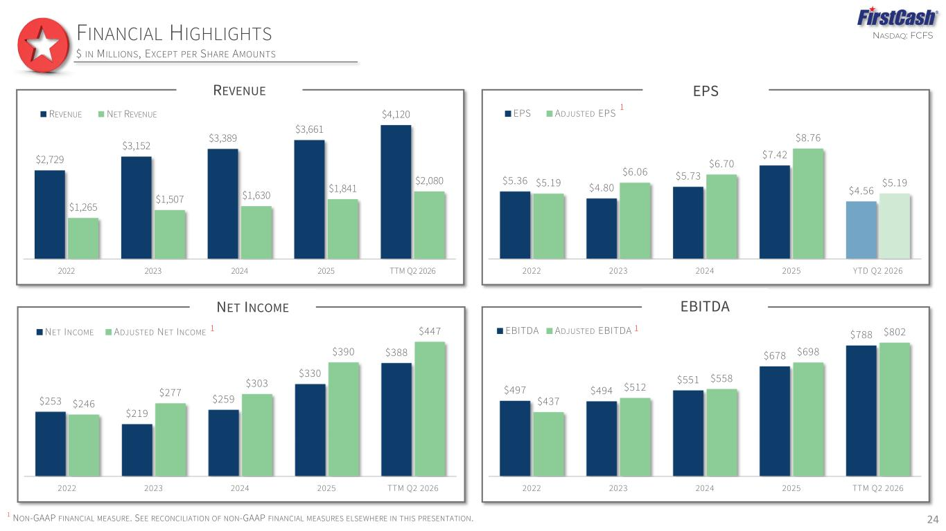
NASDAQ: FCFS REVENUE $2,729 $3,152 $3,389 $3,661 $4,120 $1,265 $1,507 $1,630 $1,841 $2,080 2022 2023 2024 2025 TTM Q2 2026 REVENUE NET REVENUE FINANCIAL HIGHLIGHTS $ IN MILLIONS, EXCEPT PER SHARE AMOUNTS 1 NON-GAAP FINANCIAL MEASURE. SEE RECONCILIATION OF NON-GAAP FINANCIAL MEASURES ELSEWHERE IN THIS PRESENTATION. EPS $5.36 $4.80 $5.73 $7.42 $4.56 $5.19 $6.06 $6.70 $8.76 $5.19 2022 2023 2024 2025 YTD Q2 2026 EPS ADJUSTED EPS 1 EBITDA $497 $494 $551 $678 $788 $437 $512 $558 $698 $802 2022 2023 2024 2025 TTM Q2 2026 EBITDA ADJUSTED EBITDA 1 NET INCOME $253 $219 $259 $330 $388 $246 $277 $303 $390 $447 2022 2023 2024 2025 TTM Q2 2026 NET INCOME ADJUSTED NET INCOME 1 24

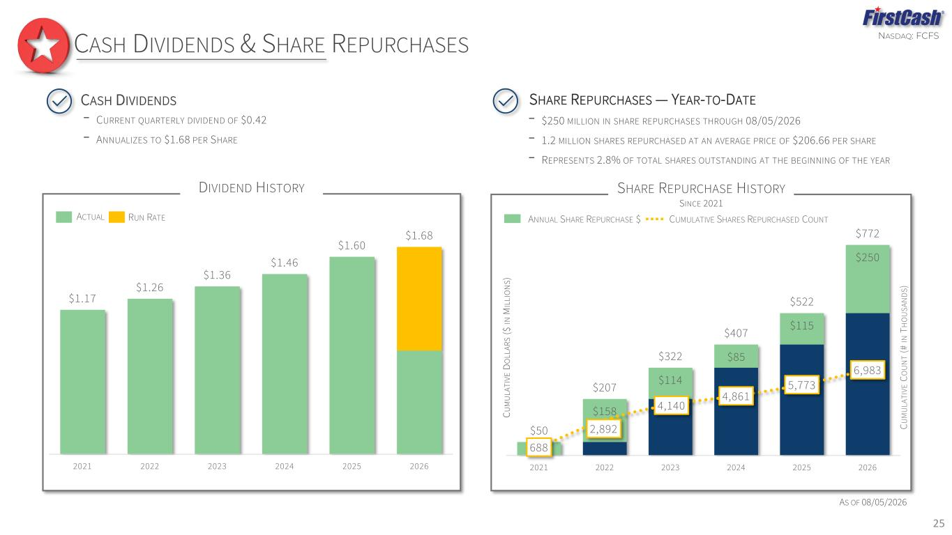
NASDAQ: FCFS SHARE REPURCHASE HISTORY SINCE 2021 $158 $114 $85 $115 $250 $50 $207 $322 $407 $522 $772 688 2,892 4,140 4,861 5,773 6,983 0 5 , 0 0 0 1 0 , 0 0 0 1 5 , 0 0 0 2 0 , 0 0 0 $ 0 $ 1 0 0 $ 2 0 0 $ 3 0 0 $ 4 0 0 $ 5 0 0 $ 6 0 0 $ 7 0 0 $ 8 0 0 $ 9 0 0 2021 2022 2023 2024 2025 2026 C U M U LA T IV E C O U N T ( # IN T H O U S A N D S ) C U M U LA T IV E D O LL A R S ( $ IN M IL LI O N S ) DIVIDEND HISTORY $1.17 $1.26 $1.36 $1.46 $1.60 $1.68 2021 2022 2023 2024 2025 2026 25 CASH DIVIDENDS & SHARE REPURCHASES AS OF 08/05/2026 ACTUAL RUN RATE ANNUAL SHARE REPURCHASE $ CUMULATIVE SHARES REPURCHASED COUNT CASH DIVIDENDS SHARE REPURCHASES — YEAR-TO-DATE - $250 MILLION IN SHARE REPURCHASES THROUGH 08/05/2026 - 1.2 MILLION SHARES REPURCHASED AT AN AVERAGE PRICE OF $206.66 PER SHARE - REPRESENTS 2.8% OF TOTAL SHARES OUTSTANDING AT THE BEGINNING OF THE YEAR - CURRENT QUARTERLY DIVIDEND OF $0.42 - ANNUALIZES TO $1.68 PER SHARE

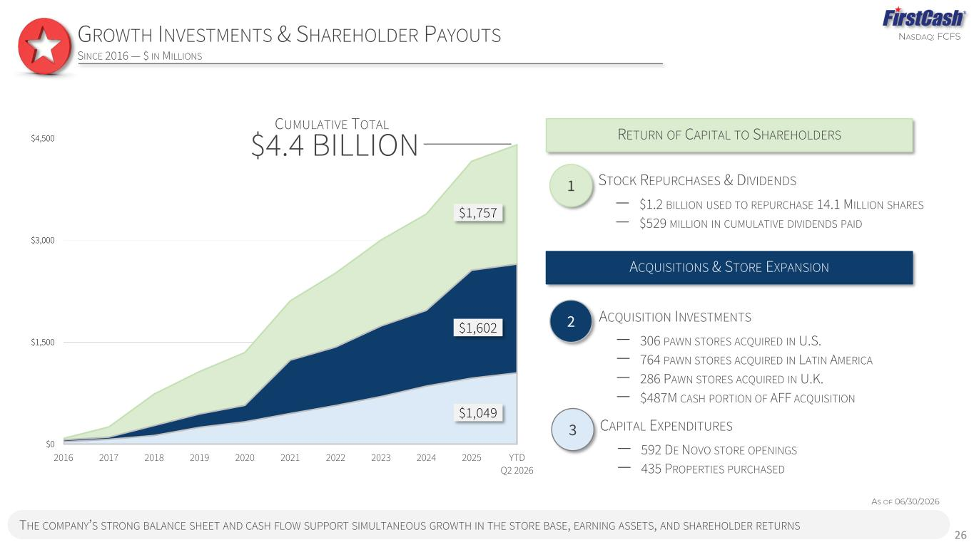
NASDAQ: FCFS THE COMPANY’S STRONG BALANCE SHEET AND CASH FLOW SUPPORT SIMULTANEOUS GROWTH IN THE STORE BASE, EARNING ASSETS, AND SHAREHOLDER RETURNS GROWTH INVESTMENTS & SHAREHOLDER PAYOUTS SINCE 2016 — $ IN MILLIONS 26 $0 $1,500 $3,000 $4,500 2016 2017 2018 2019 2020 2021 2022 2023 2024 2025 YTD Q2 2026 CUMULATIVE TOTAL $4.4 BILLION STOCK REPURCHASES & DIVIDENDS ‒ $1.2 BILLION USED TO REPURCHASE 14.1 MILLION SHARES ‒ $529 MILLION IN CUMULATIVE DIVIDENDS PAID 1 RETURN OF CAPITAL TO SHAREHOLDERS ACQUISITION INVESTMENTS ‒ 306 PAWN STORES ACQUIRED IN U.S. ‒ 764 PAWN STORES ACQUIRED IN LATIN AMERICA ‒ 286 PAWN STORES ACQUIRED IN U.K. ‒ $487M CASH PORTION OF AFF ACQUISITION CAPITAL EXPENDITURES ‒ 592 DE NOVO STORE OPENINGS ‒ 435 PROPERTIES PURCHASED 2 3 ACQUISITIONS & STORE EXPANSION AS OF 06/30/2026 $1,049 $1,757 $1,602

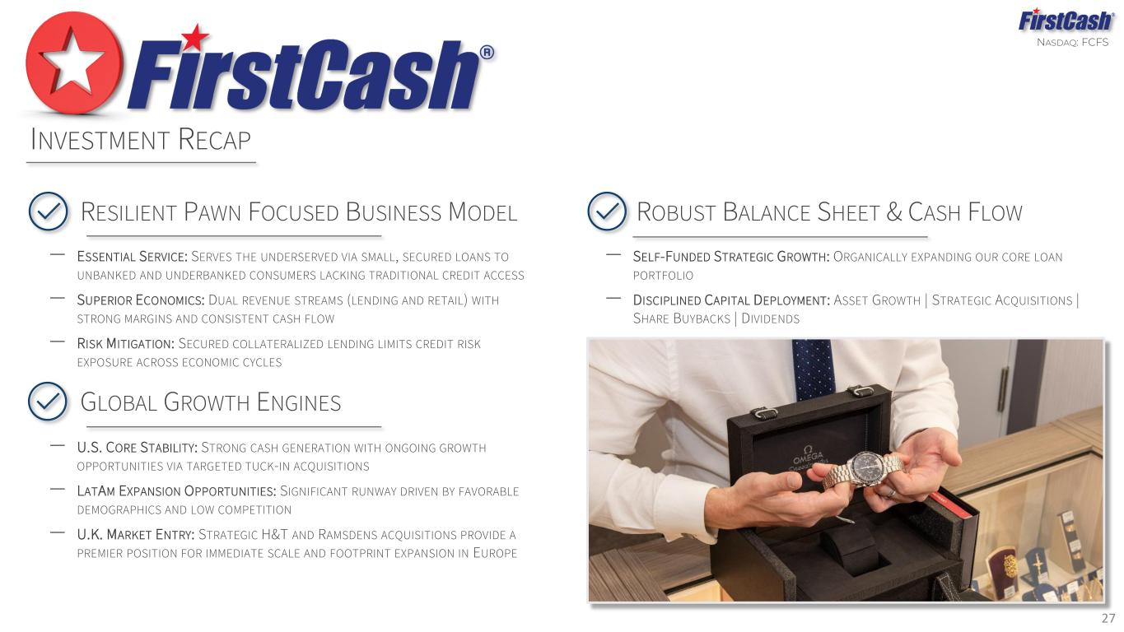
NASDAQ: FCFS 27 INVESTMENT RECAP GLOBAL GROWTH ENGINES ‒ U.S. CORE STABILITY: STRONG CASH GENERATION WITH ONGOING GROWTH OPPORTUNITIES VIA TARGETED TUCK-IN ACQUISITIONS ‒ LATAM EXPANSION OPPORTUNITIES: SIGNIFICANT RUNWAY DRIVEN BY FAVORABLE DEMOGRAPHICS AND LOW COMPETITION ‒ U.K. MARKET ENTRY: STRATEGIC H&T AND RAMSDENS ACQUISITIONS PROVIDE A PREMIER POSITION FOR IMMEDIATE SCALE AND FOOTPRINT EXPANSION IN EUROPE RESILIENT PAWN FOCUSED BUSINESS MODEL ‒ ESSENTIAL SERVICE: SERVES THE UNDERSERVED VIA SMALL, SECURED LOANS TO UNBANKED AND UNDERBANKED CONSUMERS LACKING TRADITIONAL CREDIT ACCESS ‒ SUPERIOR ECONOMICS: DUAL REVENUE STREAMS (LENDING AND RETAIL) WITH STRONG MARGINS AND CONSISTENT CASH FLOW ‒ RISK MITIGATION: SECURED COLLATERALIZED LENDING LIMITS CREDIT RISK EXPOSURE ACROSS ECONOMIC CYCLES ROBUST BALANCE SHEET & CASH FLOW ‒ SELF-FUNDED STRATEGIC GROWTH: ORGANICALLY EXPANDING OUR CORE LOAN PORTFOLIO ‒ DISCIPLINED CAPITAL DEPLOYMENT: ASSET GROWTH | STRATEGIC ACQUISITIONS | SHARE BUYBACKS | DIVIDENDS

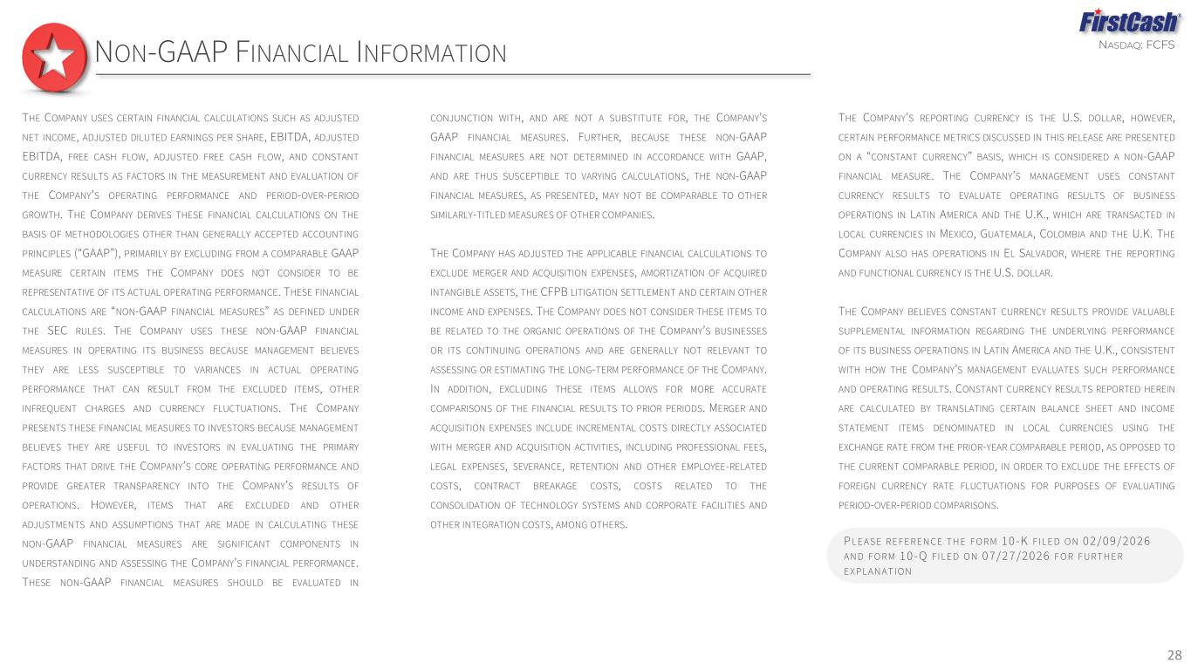
NASDAQ: FCFS THE COMPANY USES CERTAIN FINANCIAL CALCULATIONS SUCH AS ADJUSTED NET INCOME, ADJUSTED DILUTED EARNINGS PER SHARE, EBITDA, ADJUSTED EBITDA, FREE CASH FLOW, ADJUSTED FREE CASH FLOW, AND CONSTANT CURRENCY RESULTS AS FACTORS IN THE MEASUREMENT AND EVALUATION OF THE COMPANY’S OPERATING PERFORMANCE AND PERIOD-OVER-PERIOD GROWTH. THE COMPANY DERIVES THESE FINANCIAL CALCULATIONS ON THE BASIS OF METHODOLOGIES OTHER THAN GENERALLY ACCEPTED ACCOUNTING PRINCIPLES (“GAAP”), PRIMARILY BY EXCLUDING FROM A COMPARABLE GAAP MEASURE CERTAIN ITEMS THE COMPANY DOES NOT CONSIDER TO BE REPRESENTATIVE OF ITS ACTUAL OPERATING PERFORMANCE. THESE FINANCIAL CALCULATIONS ARE “NON-GAAP FINANCIAL MEASURES” AS DEFINED UNDER THE SEC RULES. THE COMPANY USES THESE NON-GAAP FINANCIAL MEASURES IN OPERATING ITS BUSINESS BECAUSE MANAGEMENT BELIEVES THEY ARE LESS SUSCEPTIBLE TO VARIANCES IN ACTUAL OPERATING PERFORMANCE THAT CAN RESULT FROM THE EXCLUDED ITEMS, OTHER INFREQUENT CHARGES AND CURRENCY FLUCTUATIONS. THE COMPANY PRESENTS THESE FINANCIAL MEASURES TO INVESTORS BECAUSE MANAGEMENT BELIEVES THEY ARE USEFUL TO INVESTORS IN EVALUATING THE PRIMARY FACTORS THAT DRIVE THE COMPANY’S CORE OPERATING PERFORMANCE AND PROVIDE GREATER TRANSPARENCY INTO THE COMPANY’S RESULTS OF OPERATIONS. HOWEVER, ITEMS THAT ARE EXCLUDED AND OTHER ADJUSTMENTS AND ASSUMPTIONS THAT ARE MADE IN CALCULATING THESE NON-GAAP FINANCIAL MEASURES ARE SIGNIFICANT COMPONENTS IN UNDERSTANDING AND ASSESSING THE COMPANY’S FINANCIAL PERFORMANCE. THESE NON-GAAP FINANCIAL MEASURES SHOULD BE EVALUATED IN CONJUNCTION WITH, AND ARE NOT A SUBSTITUTE FOR, THE COMPANY’S GAAP FINANCIAL MEASURES. FURTHER, BECAUSE THESE NON-GAAP FINANCIAL MEASURES ARE NOT DETERMINED IN ACCORDANCE WITH GAAP, AND ARE THUS SUSCEPTIBLE TO VARYING CALCULATIONS, THE NON-GAAP FINANCIAL MEASURES, AS PRESENTED, MAY NOT BE COMPARABLE TO OTHER SIMILARLY-TITLED MEASURES OF OTHER COMPANIES. THE COMPANY HAS ADJUSTED THE APPLICABLE FINANCIAL CALCULATIONS TO EXCLUDE MERGER AND ACQUISITION EXPENSES, AMORTIZATION OF ACQUIRED INTANGIBLE ASSETS, THE CFPB LITIGATION SETTLEMENT AND CERTAIN OTHER INCOME AND EXPENSES. THE COMPANY DOES NOT CONSIDER THESE ITEMS TO BE RELATED TO THE ORGANIC OPERATIONS OF THE COMPANY’S BUSINESSES OR ITS CONTINUING OPERATIONS AND ARE GENERALLY NOT RELEVANT TO ASSESSING OR ESTIMATING THE LONG-TERM PERFORMANCE OF THE COMPANY. IN ADDITION, EXCLUDING THESE ITEMS ALLOWS FOR MORE ACCURATE COMPARISONS OF THE FINANCIAL RESULTS TO PRIOR PERIODS. MERGER AND ACQUISITION EXPENSES INCLUDE INCREMENTAL COSTS DIRECTLY ASSOCIATED WITH MERGER AND ACQUISITION ACTIVITIES, INCLUDING PROFESSIONAL FEES, LEGAL EXPENSES, SEVERANCE, RETENTION AND OTHER EMPLOYEE-RELATED COSTS, CONTRACT BREAKAGE COSTS, COSTS RELATED TO THE CONSOLIDATION OF TECHNOLOGY SYSTEMS AND CORPORATE FACILITIES AND OTHER INTEGRATION COSTS, AMONG OTHERS. THE COMPANY’S REPORTING CURRENCY IS THE U.S. DOLLAR, HOWEVER, CERTAIN PERFORMANCE METRICS DISCUSSED IN THIS RELEASE ARE PRESENTED ON A “CONSTANT CURRENCY” BASIS, WHICH IS CONSIDERED A NON-GAAP FINANCIAL MEASURE. THE COMPANY’S MANAGEMENT USES CONSTANT CURRENCY RESULTS TO EVALUATE OPERATING RESULTS OF BUSINESS OPERATIONS IN LATIN AMERICA AND THE U.K., WHICH ARE TRANSACTED IN LOCAL CURRENCIES IN MEXICO, GUATEMALA, COLOMBIA AND THE U.K. THE COMPANY ALSO HAS OPERATIONS IN EL SALVADOR, WHERE THE REPORTING AND FUNCTIONAL CURRENCY IS THE U.S. DOLLAR. THE COMPANY BELIEVES CONSTANT CURRENCY RESULTS PROVIDE VALUABLE SUPPLEMENTAL INFORMATION REGARDING THE UNDERLYING PERFORMANCE OF ITS BUSINESS OPERATIONS IN LATIN AMERICA AND THE U.K., CONSISTENT WITH HOW THE COMPANY’S MANAGEMENT EVALUATES SUCH PERFORMANCE AND OPERATING RESULTS. CONSTANT CURRENCY RESULTS REPORTED HEREIN ARE CALCULATED BY TRANSLATING CERTAIN BALANCE SHEET AND INCOME STATEMENT ITEMS DENOMINATED IN LOCAL CURRENCIES USING THE EXCHANGE RATE FROM THE PRIOR-YEAR COMPARABLE PERIOD, AS OPPOSED TO THE CURRENT COMPARABLE PERIOD, IN ORDER TO EXCLUDE THE EFFECTS OF FOREIGN CURRENCY RATE FLUCTUATIONS FOR PURPOSES OF EVALUATING PERIOD-OVER-PERIOD COMPARISONS. 28 P LE AS E RE F E RE N CE T H E F O RM 10-K F I LE D O N 02/09/2026 AN D F O RM 10-Q F I LE D O N 07/27/2026 F O R F URT H E R E XP LAN AT I ON NON-GAAP FINANCIAL INFORMATION

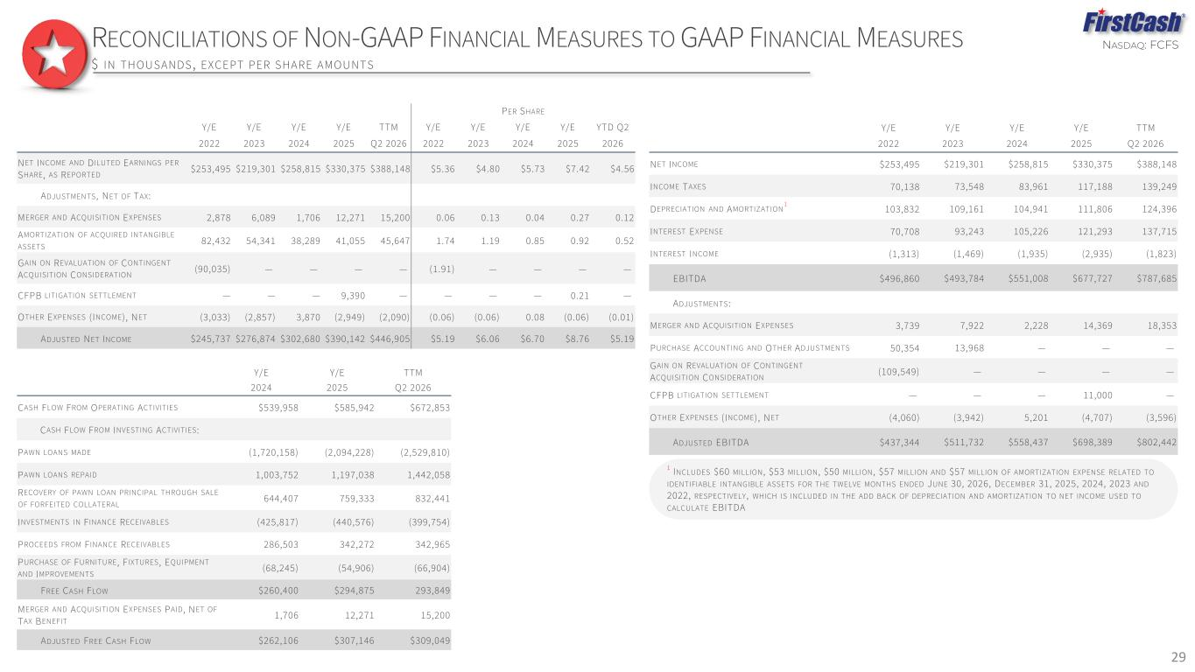
NASDAQ: FCFS 29 RECONCILIATIONS OF NON-GAAP FINANCIAL MEASURES TO GAAP FINANCIAL MEASURES $ IN THOUSANDS , EXCEPT PER SHARE AMOUNTS PER SHARE Y/E Y/E Y/E Y/E TTM Y/E Y/E Y/E Y/E YTD Q2 2022 2023 2024 2025 Q2 2026 2022 2023 2024 2025 2026 NET INCOME AND DILUTED EARNINGS PER SHARE, AS REPORTED $253,495 $219,301 $258,815 $330,375 $388,148 $5.36 $4.80 $5.73 $7.42 $4.56 ADJUSTMENTS, NET OF TAX: MERGER AND ACQUISITION EXPENSES 2,878 6,089 1,706 12,271 15,200 0.06 0.13 0.04 0.27 0.12 AMORTIZATION OF ACQUIRED INTANGIBLE ASSETS 82,432 54,341 38,289 41,055 45,647 1.74 1.19 0.85 0.92 0.52 GAIN ON REVALUATION OF CONTINGENT ACQUISITION CONSIDERATION (90,035) — — — — (1.91) — — — — CFPB LITIGATION SETTLEMENT — — — 9,390 — — — — 0.21 — OTHER EXPENSES (INCOME), NET (3,033) (2,857) 3,870 (2,949) (2,090) (0.06) (0.06) 0.08 (0.06) (0.01) ADJUSTED NET INCOME $245,737 $276,874 $302,680 $390,142 $446,905 $5.19 $6.06 $6.70 $8.76 $5.19 Y/E Y/E Y/E Y/E TTM 2022 2023 2024 2025 Q2 2026 NET INCOME $253,495 $219,301 $258,815 $330,375 $388,148 INCOME TAXES 70,138 73,548 83,961 117,188 139,249 DEPRECIATION AND AMORTIZATION 1 103,832 109,161 104,941 111,806 124,396 INTEREST EXPENSE 70,708 93,243 105,226 121,293 137,715 INTEREST INCOME (1,313) (1,469) (1,935) (2,935) (1,823) EBITDA $496,860 $493,784 $551,008 $677,727 $787,685 ADJUSTMENTS: MERGER AND ACQUISITION EXPENSES 3,739 7,922 2,228 14,369 18,353 PURCHASE ACCOUNTING AND OTHER ADJUSTMENTS 50,354 13,968 — — — GAIN ON REVALUATION OF CONTINGENT ACQUISITION CONSIDERATION (109,549) — — — — CFPB LITIGATION SETTLEMENT — — — 11,000 — OTHER EXPENSES (INCOME), NET (4,060) (3,942) 5,201 (4,707) (3,596) ADJUSTED EBITDA $437,344 $511,732 $558,437 $698,389 $802,442 1 INCLUDES $60 MILLION, $53 MILLION, $50 MILLION, $57 MILLION AND $57 MILLION OF AMORTIZATION EXPENSE RELATED TO IDENTIFIABLE INTANGIBLE ASSETS FOR THE TWELVE MONTHS ENDED JUNE 30, 2026, DECEMBER 31, 2025, 2024, 2023 AND 2022, RESPECTIVELY, WHICH IS INCLUDED IN THE ADD BACK OF DEPRECIATION AND AMORTIZATION TO NET INCOME USED TO CALCULATE EBITDA Y/E Y/E TTM 2024 2025 Q2 2026 CASH FLOW FROM OPERATING ACTIVITIES $539,958 $585,942 $672,853 CASH FLOW FROM INVESTING ACTIVITIES: PAWN LOANS MADE (1,720,158) (2,094,228) (2,529,810) PAWN LOANS REPAID 1,003,752 1,197,038 1,442,058 RECOVERY OF PAWN LOAN PRINCIPAL THROUGH SALE OF FORFEITED COLLATERAL 644,407 759,333 832,441 INVESTMENTS IN F INANCE RECEIVABLES (425,817) (440,576) (399,754) PROCEEDS FROM F INANCE RECEIVABLES 286,503 342,272 342,965 PURCHASE OF FURNITURE, F IXTURES, EQUIPMENT AND IMPROVEMENTS (68,245) (54,906) (66,904) FREE CASH FLOW $260,400 $294,875 293,849 MERGER AND ACQUISITION EXPENSES PAID, NET OF TAX BENEFIT 1,706 12,271 15,200 ADJUSTED FREE CASH FLOW $262,106 $307,146 $309,049

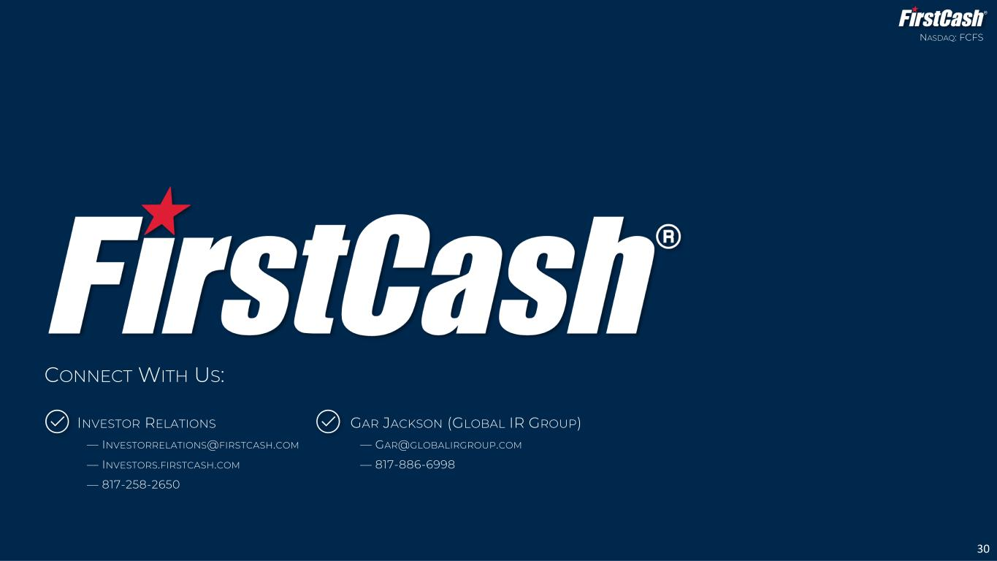
INVESTOR RELATIONS — INVESTORRELATIONS@FIRSTCASH.COM — INVESTORS.FIRSTCASH.COM — 817-258-2650 NASDAQ: FCFS 30 CONNECT WITH US: GAR JACKSON (GLOBAL IR GROUP) — GAR@GLOBALIRGROUP.COM — 817-886-6998

